CLUSTER | NAT: NATURAL RESOURCES
OCCUPATION | Wildlife
HAZARD CONTROLS | TOOL—FIREARMS
Engineering Controls | 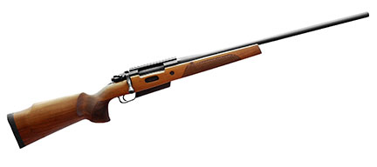  iStockphoto/Thinkstock
- Use trigger locks.
Administrative Controls
- Remind students that improperly using firearms may result in serious injury or death. Teach students the vital four ACTS of firearm safety:
- Assume every firearm is loaded.
- Control the muzzle direction at all times.
- Trigger finger must be kept off the trigger and out of the trigger guard.
- See that the firearm is unloaded—prove it is safe.

- Always use safe handling techniques.

- Follow the school safety policy.

- Provide and document ongoing safety education and training, including mandatory equipment and tool orientation.

- Tag and remove defective tools from service.

- Ensure the tool is appropriate for the work to be done.

- Establish handwashing practices.

- Provide safe clearance for the tool.

- Provide a first aid kit and supplies, including an eyewash station and biohazard disposal.

- Keep the manufacturer’s manual for the tool. Read and follow manufacturer instructions, precautions, and directions for proper use, safety, maintenance, and cleaning.

- Since each firearm has different safety mechanisms, individuals should use their firearms in accordance with manufacturer specifications and should contact individual manufacturers to obtain further information.

- Provide initial training to include a thorough review of hazards and accidents associated with the task.

- Identify and secure cleaning materials that are less toxic and harmful to the students.

- Develop and communicate safe work practices and procedures for hazardous work or situations.

- Ensure repetitive tasks are properly paced.

- Maintain classroom supervision at all times.

- Teach, transport, and store firearms in accordance with Canada’s Firearms Act (http://laws-lois.justice.gc.ca/eng/acts/F-11.6 and http://laws-lois.justice.gc.ca/eng/regulations/SOR-98-209/page-2.html#h-3).
Personal Protective Equipment (PPE)
- eye protection
- proper footwear, depending on the task
- ear protection

