CLUSTER | NAT: NATURAL RESOURCES
OCCUPATION | Wildlife
HAZARD CONTROLS | TOOL—FISH NET
Engineering Controls | 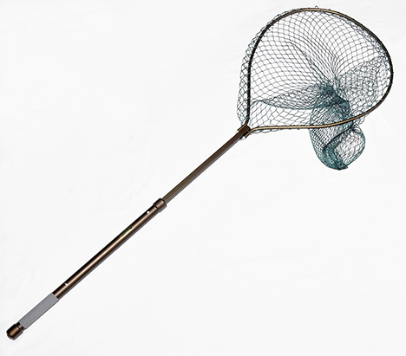  © Marco2811/29233843/Fotolia
- n/a
Administrative Controls
- Follow the school safety policy.

- Provide and document ongoing safety education and training, including mandatory equipment and tool orientation.

- Tag and remove defective tools from service.

- Ensure the tool is appropriate for the work to be done.

- Establish handwashing practices.

- Provide a first aid kit and supplies, including an eyewash station and biohazard disposal.

- Keep the manufacturer’s manual for the tool. Read and follow manufacturer instructions, precautions, and directions for proper use, safety, maintenance, and cleaning.

- Provide initial training to include a thorough review of hazards and accidents associated with the job.

- Develop and communicate safe work practices and procedures for hazardous work or situations.

- Ensure repetitive tasks are properly paced.

- Substitute a hazardous cleaning agent with a safer, environmentally friendly one. Instruct students to wear PPE during cleaning.
Personal Protective Equipment (PPE)
- latex gloves or hypoallergenic alternative while cleaning
- safety glasses or goggles
- non-slip footwear

