CLUSTER | NAT: NATURAL RESOURCES
OCCUPATION | Wildlife
HAZARD CONTROLS | TOOLS—HOOK, LURE, SWIVEL, LEADER, SINKER, DOWN RIGGER, FLOAT
Engineering Controls | 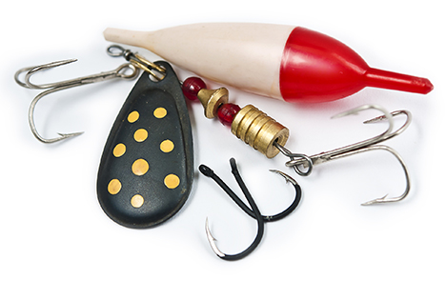  iStockphoto/Thinkstock
- fishing kit or box for safe storage of sharp hooks
Administrative Controls
- Follow the school safety policy.

- Provide and document ongoing safety education and training, including mandatory equipment and tool orientation.

- Tag and remove defective tools from service.

- Ensure the tool is appropriate for the work to be done.

- Establish handwashing practices.

- Provide a first aid kit and supplies, including an eyewash station and biohazard disposal.

- Keep the manufacturer’s manual for the tool. Read and follow manufacturer instructions, precautions, and directions for proper use, safety, maintenance, and cleaning.

- Provide initial training to include a thorough review of hazards and accidents associated with the task.

- Develop and communicate safe work practices and procedures for hazardous work or situations.

- Identify and secure materials that are less toxic and harmful to the students and environment.

- Ensure repetitive tasks are properly paced.
Personal Protective Equipment (PPE)
- protective eyewear

