CLUSTER | NAT: NATURAL RESOURCES
OCCUPATION | Wildlife
HAZARD CONTROLS | TOOL— KNIFE
Engineering Controls | 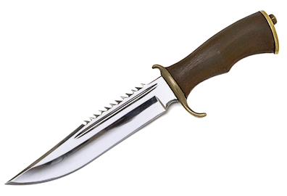  Hemera/Thinkstock
- sheath
Administrative Controls
- Store the knife in its sheath when not in use.

- Choose a knife based on the tasks it will be used for and the environment it will be used in.

- Always adhere to safe knife-handling procedures.

- Follow the school safety policy.

- Provide and document ongoing safety education and training, including mandatory equipment and tool orientation.

- Tag and remove defective tools from service.

- Establish handwashing practices.

- Provide a first aid kit and supplies, including an eyewash station and biohazard disposal.

- Keep the manufacturer’s manual for the tool. Read and follow manufacturer instructions, precautions, and directions for use and for proper safety, maintenance, and cleaning.

- Provide initial training to include a thorough review of hazards and accidents associated with the task.

- Develop and communicate safe work practices and procedures for hazardous work or situations.

- Ensure repetitive tasks are properly paced.
Personal Protective Equipment (PPE)
- n/a

