CLUSTER | NAT: NATURAL RESOURCES
OCCUPATION | Wildlife
HAZARD CONTROLS | TOOL—PADDLE
Engineering Controls | 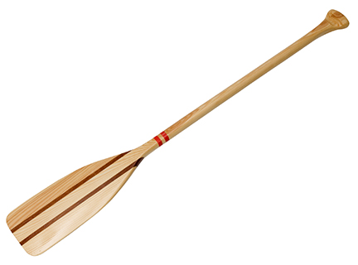  Hemera/Thinkstock
- n/a
Administrative Controls
- Choose the appropriate size, shape, and construction of paddle for the activity.

- Follow the school safety policy.

- Provide and document ongoing safety education and training, including mandatory equipment and tool orientation.

- Tag and remove defective tools from service.

- Establish handwashing practices.

- Provide a first aid kit and supplies, including an eyewash station and biohazard disposal.

- Keep the manufacturer’s manual for the tool. Read and follow manufacturer instructions, precautions, and directions for proper safety, maintenance, and cleaning.

- Develop and communicate safe paddling practices and procedures for hazardous situations.

- Ensure repetitive tasks are properly paced.

- Instruct students to wear a life jacket or PDF when boating.
Personal Protective Equipment (PPE)
- PFD or life jacket, when boating

