CLUSTER | NAT: NATURAL RESOURCES
OCCUPATION | Wildlife
HAZARD CONTROLS | TOOL—QUIVER
Engineering Controls | 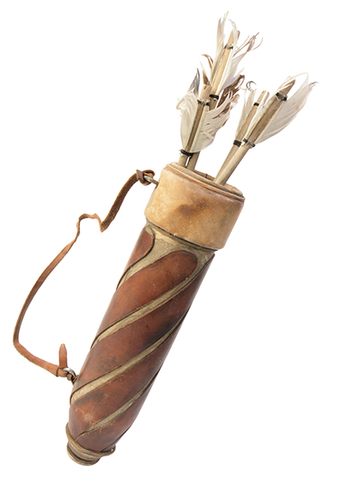  Ablestock.com/Thinkstock
- n/a
Administrative Controls
- Follow the school safety policy.

- Provide and document ongoing safety education and training, including mandatory equipment and tool orientation.

- Tag and remove defective tools from service.

- Establish handwashing practices.

- Provide a first aid kit and supplies, including an eyewash station and biohazard disposal.

- Keep the manufacturer’s manual for the tool. Read and follow manufacturer instructions, precautions, and directions for proper safety, maintenance, and cleaning.

- Provide initial training to include a thorough review of hazards and accidents associated with the job.

- Substitute a hazardous cleaning agent with a safer, environmentally friendly one.

- Develop and communicate safe work practices and procedures for hazardous work or situations.

- Maintain class supervision at all times.
Personal Protective Equipment (PPE)
- latex gloves or hypoallergenic alternative when cleaning quiver

