CLUSTER | NAT: NATURAL RESOURCES
OCCUPATION | Wildlife
HAZARD CONTROLS | TOOL—SURVIVAL KIT
Engineering Controls | 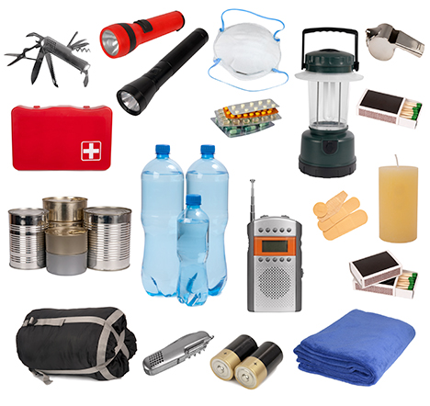  iStockphoto/Thinkstock  Contents may include the following:  - duct tape  - pencil  - waterproof paper  - safety pins  - sewing needle  - sewing thread  - heavy duty aluminum foil  - compass  - fish hooks  - magnifying glass  - braided nylon cord  - disposable sterile scalpel  - signal mirror or rescue flash  - matches  - emergency fire starter (e.g., magnesium fire starter)  - whistle
- n/a
Administrative Controls
- Follow the school safety policy.

- Provide and document ongoing safety education and training, including mandatory equipment and tool orientation.

- Tag and remove defective tools from service.

- Ensure the tool is appropriate for the task to be done.

- Establish handwashing practices.

- Provide a first aid kit and supplies, including an eyewash station and biohazard disposal.

- Keep the manufacturer’s manual for the tool. Read and follow manufacturer instructions, precautions, and directions for proper safety, maintenance, and cleaning.

- Provide initial training to include a thorough review of hazards and accidents associated with the task.

- Teach emergency procedures.

- Develop and communicate safe work practices and procedures for hazardous work or situations.

- Check the contents of survival kit before using to make sure there are no damaged or expired products.
Personal Protective Equipment (PPE)
- n/a

