CLUSTER | NAT: NATURAL RESOURCES
OCCUPATION | Wildlife
HAZARD CONTROLS | EQUIPMENT—TENT
Engineering Controls | 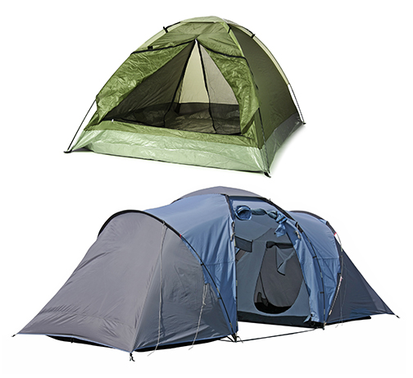  top: © Africa Studio/37708095/Fotolia  bottom: © tsach/33978613/Fotolia
- n/a
Administrative Controls
- Follow the school safety policy.

- Provide and document ongoing safety education and training, including mandatory equipment and tool orientation.

- Tag and remove defective tools from service.

- Choose an appropriate tent. Ensure the equipment is appropriate for the task to be done.

- Establish handwashing practices.

- Provide a first aid kit and supplies, including an eyewash station and biohazard disposal.

- Keep the manufacturer’s manual for the equipment. Read and follow manufacturer instructions, precautions, and directions for proper set-up, takedown, placement, safety, maintenance, and cleaning.

- Train students to set up, take down, and use the tent safely.

- Provide initial training to include a thorough review of hazards and accidents associated with the task.
Personal Protective Equipment (PPE)
- n/a

