CLUSTER | NAT: NATURAL RESOURCES
OCCUPATION | Wildlife
HAZARD CONTROLS | TOOL—WATER PURIFICATION (BOILING, FILTRATION, AND CHEMICAL)
Engineering Controls | 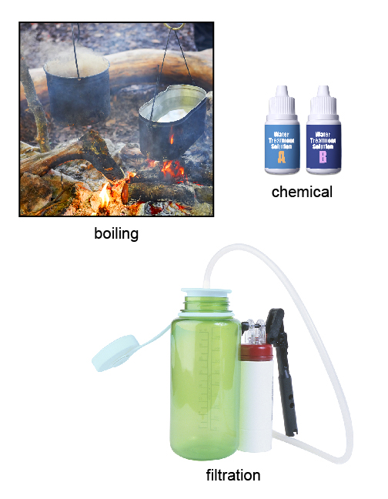  boiling: © Pavel Vakhrushev/shutterstock  chemical: adapted from © Picsfive/shutterstock  filtration: adapted from Hemera Technologies/PhotoObjects.net/  Thinkstock
- n/a
Administrative Controls
- Follow the school safety policy.

- Provide and document ongoing safety education and training, including mandatory equipment and tool orientation.

- Tag and remove defective tools from service.

- Ensure the tool is appropriate for the work to be done.

- Establish handwashing practices.

- Provide a first aid kit and supplies, including an eyewash station and biohazard disposal.

- Keep the manufacturer’s manual for the tool. Read and follow manufacturer instructions, precautions, and directions for proper use, safety, maintenance, and cleaning.

- Water treatment methods should be tested prior to going into the backcountry.

- Provide initial training to include a thorough review of hazards and accidents associated with the job.

- Develop and communicate safe work practices and procedures for hazardous work or situations.
Personal Protective Equipment (PPE)
- n/a

