My Health and Safety Questions eLearning Program

Name: | Date:
CTS Instructional Area:

The My Health and Safety Questions eLearning Program from Work Safe Alberta is an illustrative, interactive online training tool that follows a new worker as he begins his new job.

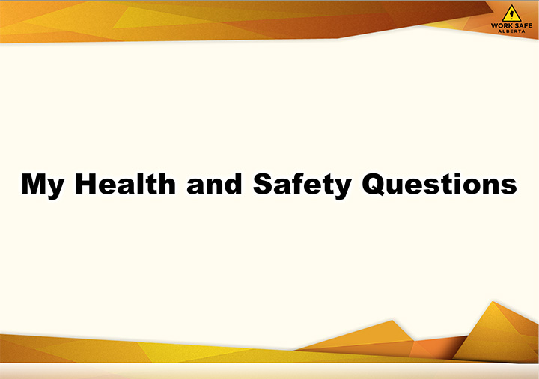
© 2011 Government of Alberta. Labour. Work Safe Alberta

1. Click on the link to begin the eLearning program: http://work.alberta.ca/elearning/questions/MyHealthAndSafetyQuestions.html

2. Use the table that follows to record a summary of your eLearning program. If you need more space, use additional paper.

eLearning Program Summary
Title:

