PPE Fashion Show

Name: | Date:
CTS Instructional Area:

Work in teams of two to put on a fashion show for your instructional area. The theme of the fashion show is “PPE Is Cool! Suit Up—Wear the Gear!” Compete against classmates for the top spot.

1. Invite everyone in the class to identify a task or project that is routinely completed in your instructional area.

2. Write the information on a file card and drop it in a collection box.

3. Teams will draw a card and then work together to identify and model the appropriate PPE items to complete the task or project.

4. Classmates judge how successful each team’s choices of PPE are for the task or project card drawn!

Partners:

- __________________________________

- __________________________________

Task: ______________________________________________________________________

- Use the planning table to help organize the items required for your fashion show.

Personal Protective Equipment  Item | Advantages for Wearing the PPE item | Frustrations with Your PPE | Helpful Tips for Wearing Your PPE
Head:
Eyes:
Ears:
Face:
Hands:
Feet:
Body:

- Sometimes, despite best efforts to choose the best-fitting PPE, it is still not always comfortable. Identify some helpful tips for people who experience the same frustration but know that PPE is necessary to wear. Complete the two remaining columns in the table as your own personal guide. You can use the PDFs listed here to help you.
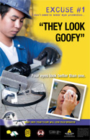 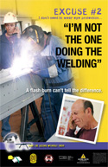 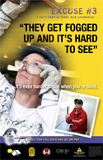 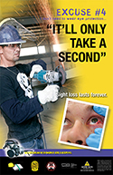
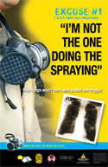 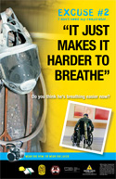
© 2009 Workers’ Compensation Board https://www.wcb.ab.ca/resources/for-employers/forms-and-guides/ (Scroll down to "Posters".)

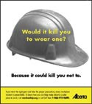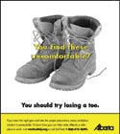
© 2011 Government of Alberta. Labour. Work Safe Alberta http://work.alberta.ca/occupational-health-safety/ohs-posters.html

