Project Flow Chart

Name: | Date:
CTS Instructional Area:

Project:
Occupational Area:

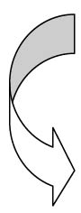
Identify all the steps that you will take to complete your project. Identify any tools, equipment, and materials that you might need. Put a star beside any steps that you will need assistance with from you teacher. Use additional space if needed.
 | Project Procedure | Tools, Equipment, and Materials

