Recognizing Workplace Hazards eLearning Program

Name: | Date:
CTS Instructional Area:

The Recognizing Workplace Hazards—See It Again for the First Time eLearning Program from Work Safe Alberta is an illustrative, interactive online training tool that discusses the five steps in field level hazard assessment.

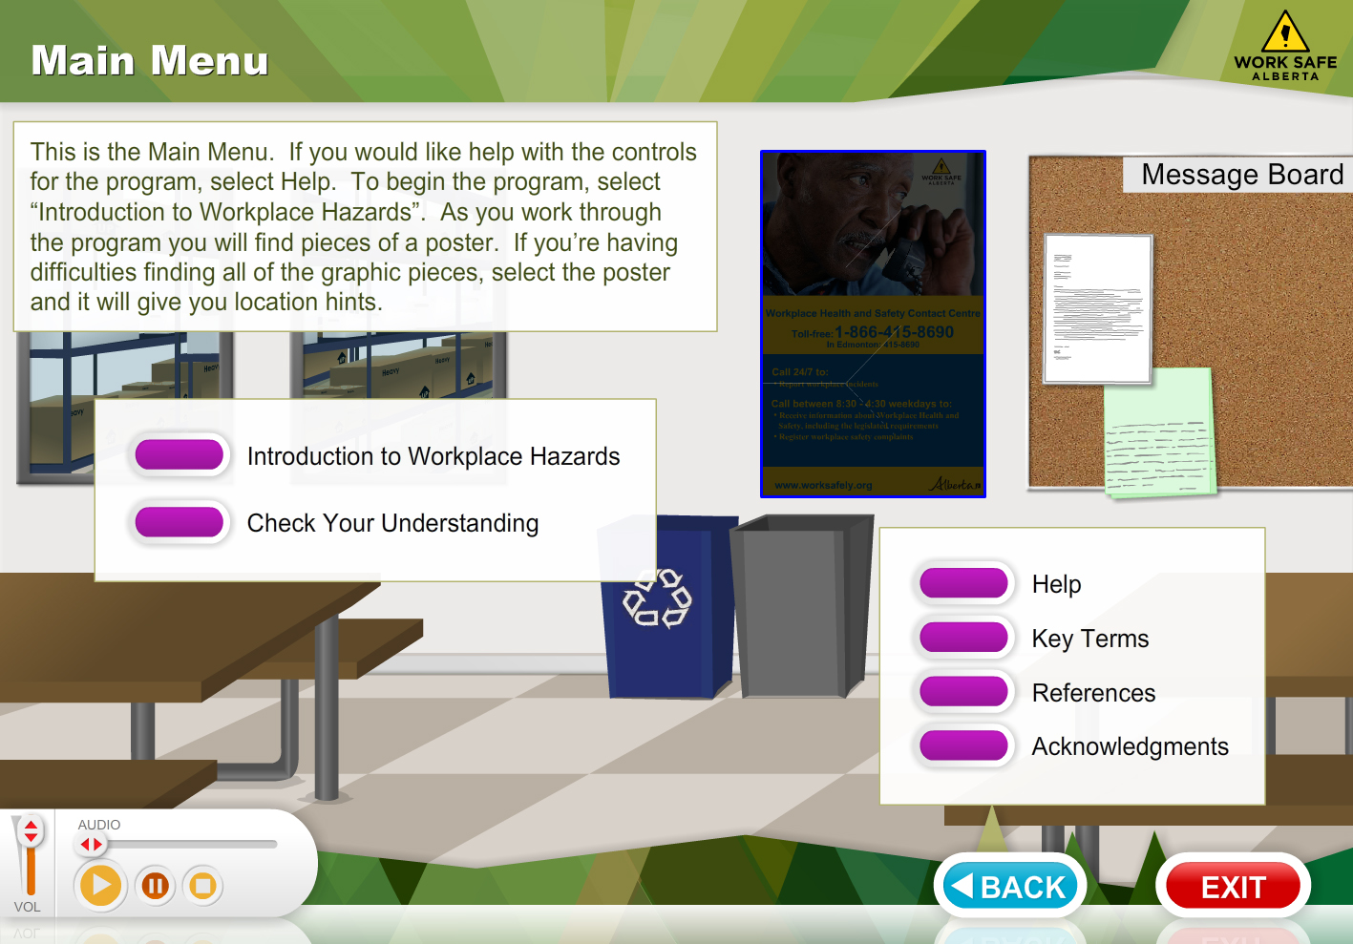
© 2011 Government of Alberta. Labour. Work Safe Alberta

1. Click on the link to begin the eLearning program: http://work.alberta.ca/elearning/WorkplaceHazards/index.html

2. Use the table that follows to record a summary of your eLearning program. If you need more space, use additional paper.

eLearning Program Summary
Title:

