CLUSTER | TMT: TRADES, MANUFACTURING, AND TRANSPORTATION
OCCUPATION | Construction
HAZARD CONTROLS | CONSUMABLES—ADHESIVES (e.g., polyvinyl acetate or white glue, aliphatic resin or yellow carpenter’s glue, polyurethane glue, epoxy resin, contact cement, cyanoacrylate)
Engineering Controls | 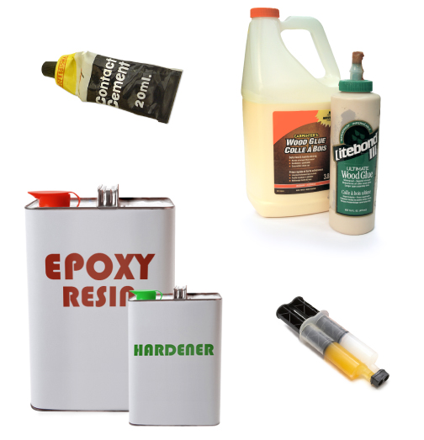  contact cement: Adapted from © Francis Wong Chee Yen/shutterstock; epoxy tins: Adapted from : Feng Yu/shutterstock; epoxy compound: Adapted from 1125089601/shutterstock
- fume extraction
- explosion-proof finishing room
- Refer to the Material Safety Data Sheet for the required level of ventilation for the specific product being used.
Administrative Controls
- Use less toxic, water-based, zero volatile organic compound (VOC) alternative adhesives.
- Wipe the respirator with a respirator wipe before and after use (if shared).

- Provide initial training to include a thorough review of hazards and accidents associated with the job.

- Follow the school safety policy.

- Provide and document ongoing safety education and training, including mandatory equipment and tool orientation.

- Outline the “imminent danger/right to refuse” procedures.

- Ensure hazard signs and tags are in place.

- Tag and remove defective tools from service.

- Ensure tools are used under competent supervision.

- Ensure the tool is appropriate for the work to be done.

- Schedule work to avoid overcrowding.

- Ensure repetitive tasks are properly paced.
- Post important emergency telephone numbers and contacts.

- Post lockdown procedures.

- Post fire drill procedures.

- Establish handwashing practices.

- Locate the emergency electrical shut-off.

- Place a non-slip surface on the floor.

- Mark lines on the floor to designate the work space.

- Ensure fire extinguishers are strategically located and marked.

- Provide a first aid kit and supplies, including an eyewash station and biohazard disposal.

- Ensure that the master control panel and panel breakers are properly labelled.

- Keep manufacturers’ manuals for the adhesives.

- Provide an ergonomically appropriate work area.

- Ensure that correct lighting is available.

- Correctly place and maintain smoke detectors and heat sensors.

- Post relevant safety and health facts in the work area.

- Ensure that students wear safe attire: no loose clothing or jewellery should be worn.

- Ensure that long hair is tied back and/or secured under a hat.

- Ensure WHMIS training is available.

- Provide up-to-date MSDS.

- Follow lock-out procedures for performing maintenance.

Personal Protective Equipment (PPE)
- chemical splash goggles

- closed footwear
- impervious gloves
- apron
- organic vapour respirator, if required by the Material Safety Data Sheet
- Refer to the Material Safety Data Sheet for the specific adhesive being used.

