CLUSTER | TMT: TRADES, MANUFACTURING, AND TRANSPORTATION
OCCUPATION | Construction
HAZARD CONTROLS | EQUIPMENT—BAND SAW
Engineering Controls | 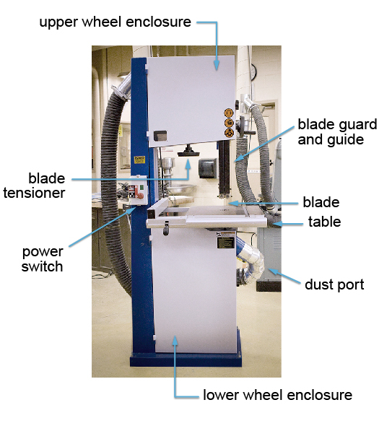  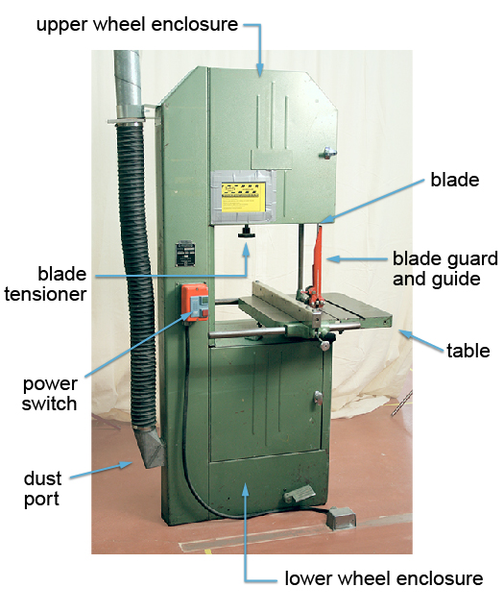
- dust extraction
- wheel enclosures
- magnetic motor starter switch
- blade guard(s)
- proper blade size and type for specific operation
- equipment securely fastened in place
Administrative Controls
- Use a minimum 5-cm or 2-in margin of safety.
- Adjust the upper blade guide 5 mm or ¼ in above stock.
- Use a V-block for cutting round stock.
- Use relief cuts when cutting curves.
- Provide initial training to include a thorough review of hazards and accidents associated with the job.

- Follow the school safety policy.

- Provide and document ongoing safety education and training, including mandatory equipment and tool orientation.

- Outline the “imminent danger/right to refuse” procedures.

- Ensure hazard signs and tags are in place.

- Tag and remove defective tools from service.

- Ensure tools are used under competent supervision.

- Ensure the equipment is appropriate for the work to be done.

- Schedule work to avoid overcrowding.

- Ensure repetitive tasks are properly paced.

- Post important emergency telephone numbers and contacts.

- Post lockdown procedures.

- Post fire drill procedures.

- Establish handwashing practices.

- Locate the emergency electrical shut-off.

- Provide safe clearance for the equipment.

- Place a non-slip surface on the floor.

- Mark lines on the floor to designate the work space.

- Ensure fire extinguishers are strategically located and marked.

- Provide a first aid kit and supplies, including an eyewash station and biohazard disposal.

- Ensure that the master control panel and panel breakers are properly labelled.

- Keep the manufacturers’ manual for the equipment.

- Provide an ergonomically appropriate work area.

- Ensure that correct lighting is available.

- Correctly place and maintain smoke detectors and heat sensors.

- Post relevant safety and health facts in the work area.

- Ensure that students wear safe attire: no loose clothing or jewellery should be worn.

- Ensure that long hair is tied back and/or secured under a hat.

- Adhere to the Canadian Electrical Code during the operation, repair, and maintenance of equipment.

- Never leave the machine unattended.

- Adhere to OHS occupational exposure limits (OELs).

- Keep sharp tools sharpened.

- Post “high-voltage” signage.

- Follow lock-out procedures for performing maintenance.
Personal Protective Equipment (PPE)
- impact-resistant safety glasses (CSA approved)
- hearing protection
- closed footwear

