CLUSTER | TMT: TRADES, MANUFACTURING, AND TRANSPORTATION
OCCUPATION | Construction
HAZARD CONTROLS | CONSUMABLES—FINISHES (e.g., oil, varnish, lacquer, paste wax, polyurethane, paint)
Engineering Controls | 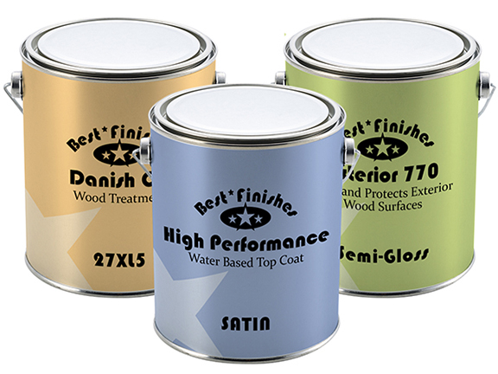Adapted from iStockphoto/Thinkstock
- fume extraction
- explosion-proof finishing room
- fireproof rag disposal bin (if a pickup service is used)
- Refer to the Material Safety Data Sheet for the required level of ventilation.
Administrative Controls
- Use less toxic, water-based, zero volatile organic compound (VOC) alternative finishes.
- Wipe the respirator with a respirator wipe before and after use (if shared).
- Follow rag disposal protocol.

- Provide initial training to include a thorough review of hazards and accidents associated with the job.

- Follow the school safety policy.

- Provide and document ongoing safety education and training, including mandatory equipment and tool orientation.

- Outline the “imminent danger/right to refuse” procedures.

- Ensure hazard signs and tags are in place.

- Tag and remove defective tools from service.

- Ensure tools are used under competent supervision.

- Ensure the tool is appropriate for the work to be done.
- Schedule work to avoid overcrowding.

- Ensure repetitive tasks are properly paced.

- Post important emergency telephone numbers and contacts.

- Post lockdown procedures.

- Post fire drill procedures.

- Establish handwashing practices.

- Locate the emergency electrical shut-off.

- Ensure fire extinguishers are strategically located and marked.

- Provide a first aid kit and supplies, including an eyewash station and biohazard disposal.

- Ensure that the master control panel and panel breakers are properly labelled.

- Keep manufacturers’ manuals for the finishes.

- Provide an ergonomically appropriate work area.

- Ensure that correct lighting is available.

- Correctly place and maintain smoke detectors and heat sensors.

- Post relevant safety and health facts in the work area.

- Ensure that students wear safe attire: no loose clothing or jewellery should be worn.

- Ensure that long hair is tied back and/or secured under a hat.

- Ensure WHMIS training is available.

- Provide up-to-date MSDS.

- Follow lock-out procedures for performing maintenance.

Personal Protective Equipment (PPE)
- chemical splash goggles

- closed footwear
- impervious gloves
- apron
- organic vapour respirator, if required by the Material Safety Data Sheet
- Refer to the Material Safety Data Sheet for the specific finish being used.

