CLUSTER | TMT: TRADES, MANUFACTURING, AND TRANSPORTATION
OCCUPATION | Fabrication
HAZARD CONTROLS | CONSUMABLE—ELECTRODES
Engineering Controls | 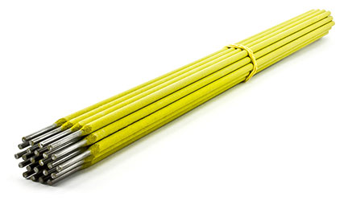  © beodra/shutterstock
- appropriate guards
- ventilation system
- dust and fume extraction equipment
Administrative Controls
- Secure and use the least toxic and harmful substance for the students and the environment. Lanthanum, cerium, yttrium, and zirconium oxides can all be used with tungsten. While they are all marginally radioactive, the risk is even lower than with thoria, so no specific precautions are needed.

- Provide initial training to include a thorough review of accidents and hazards associated with the job.

- Follow the school safety policy.

- Provide and document ongoing safety education and training, including mandatory equipment and tool orientation.

- Outline the “imminent danger/right to refuse” procedures.

- Ensure hazard signs and tags are in place.

- Tag and remove defective machines from service.

- Ensure tools are used under competent supervision.

- Ensure the tool is appropriate for the work to be done.

- Schedule work to avoid overcrowding.

- Ensure repetitive tasks are properly paced.

- Post important emergency telephone numbers and contacts.

- Post lockdown procedures.

- Post fire drill procedures.

- Establish handwashing practices.

- Locate the emergency electrical shut-off.

- Provide safe clearance for the tool.

- Place a non-slip surface on the floor.

- Mark lines on the floor to designate the work space.

- Ensure fire extinguishers are strategically located and marked.

- Provide a first aid kit and supplies, including an eyewash station and biohazard disposal.

- Ensure that the master control panel and breakers are properly labelled.

- Keep the manufacturer’s manual for the tool.

- Provide an ergonomically appropriate work area.

- Ensure that correct lighting is available.

- Correctly place and maintain smoke detectors and heat sensors.

- Post relevant safety and health facts in the work area.

- Ensure that students wear safe attire: no loose clothing or jewellery should be worn.

- Ensure that long hair is tied back and/or secured under a hat.

- Ensure WHMIS training is available.

- Provide up-to-date MSDS.

- Properly label controlled products.

- Adhere to OHS occupational exposure limits (OELs).

- Adhere to the Canadian Electrical Code during the operation, repair, and maintenance of equipment.

- Provide proper storage for consumables.

- Post “high voltage” signage.

- Follow lock-out procedures for performing maintenance.
Personal Protective Equipment (PPE)
- safety glasses (CSA approved)
- hearing protection
- gloves
- coveralls

