CLUSTER | TMT: TRADES, MANUFACTURING, AND TRANSPORTATION
OCCUPATION | Fabrication
HAZARD CONTROLS | EQUIPMENT—MILL (VERTICAL)
Engineering Controls | 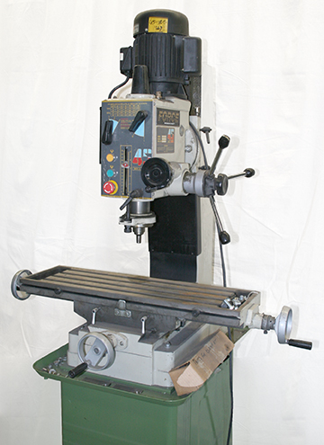  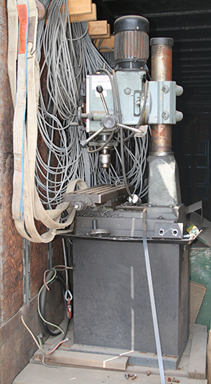  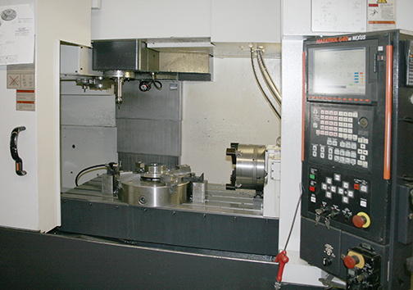
- appropriate guards
- ventilation system
- dust and fume extraction equipment
Administrative Controls
- Provide initial training to include a thorough review of hazards and accidents associated with the job.

- Follow the school safety policy.

- Provide and document ongoing safety education and training, including mandatory equipment and tool orientation.

- Outline the “imminent danger/right to refuse” procedures.

- Ensure hazard signs and tags are in place.

- Tag and remove defective equipment from service.

- Ensure equipment is used under competent supervision.

- Ensure the equipment is appropriate for the work to be done.

- Schedule work to avoid overcrowding.

- Ensure repetitive tasks are properly paced.

- Post important emergency telephone numbers and contacts.

- Post lockdown procedures.

- Post fire drill procedures.

- Establish handwashing practices.

- Locate the emergency electrical shut-off.

- Provide safe clearance for the equipment.

- Place a non-slip surface on the floor.

- Mark lines on the floor to designate the work space.

- Ensure fire extinguishers are strategically located and marked.

- Provide a first aid kit and supplies, including an eyewash station and biohazard disposal.

- Ensure that the master control panel and panel breakers are properly labelled.

- Keep the manufacturer’s manual for the equipment.

- Provide an ergonomically appropriate work area.

- Ensure that correct lighting is available.

- Correctly place and maintain smoke detectors and heat sensors.

- Post relevant safety and health facts in the work area.

- Ensure that students wear safe attire: no loose clothing or jewellery should be worn.

- Ensure that long hair is tied back and/or secured under a hat.

- Properly label controlled product containers.

- Ensure WHMIS training is available.

- Provide up-to-date MSDS.

- Ensure extension cords are not present in high-traffic areas.

- Adhere to the Canadian Electrical Code during the operation, repair, and maintenance of equipment.

- Keep sharp tools sharpened.

- Secure and use the least toxic and harmful substance for the students and the environment.

- Follow lock-out procedures for performing maintenance.

Personal Protective Equipment (PPE)
- safety glasses (CSA approved)
- hearing protection
- clear face shield
- protective clothing
- steel-toed safety boots (CSA approved)

