CLUSTER |  | TMT: TRADES, MANUFACTURING, & TRANSPORTATION
OCCUPATION |  | Logistics
HAZARD CONTROLS |  | EQUIPMENT—COMPUTER LAB
Engineering Controls |  | 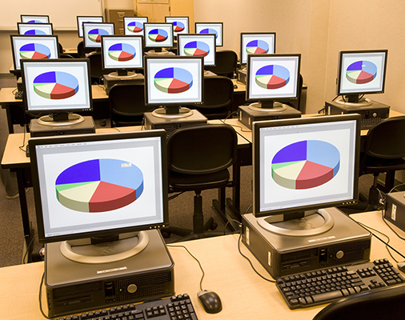  Jetta Productions/Lifesize/Thinkstock
- n/a
Administrative Controls
- Provide instruction on Internet hazards and firewall use as appropriate.

- Set-up the computers to allow the teacher an unobstructed view of the monitors.

- Provide ergonomically designed and installed chairs, desks, monitor, keyboard, and mouse.

- Ensure repetitive tasks are properly paced.

- Post important emergency telephone numbers and contacts.

- Post lockdown procedures.

- Post fire drill procedures.

- Establish handwashing practices.

- Ensure fire extinguishers are strategically located and marked.

- Provide a first aid kit and supplies, including an eyewash station and biohazard disposal.

- Ensure that the master control panel and panel breakers are properly labelled.

- Correctly place and maintain smoke detectors and heat sensors.

- Ensure that proper lighting is available.

- Prevent extension cords from becoming trip hazards in high-traffic areas.
Personal Protective Equipment (PPE)
- n/a

