CLUSTER | TMT: TRADES, MANUFACTURING, & TRANSPORTATION
OCCUPATION | Logistics
HAZARD CONTROLS | EQUIPMENT—WAREHOUSED MATERIALS
Engineering Controls | 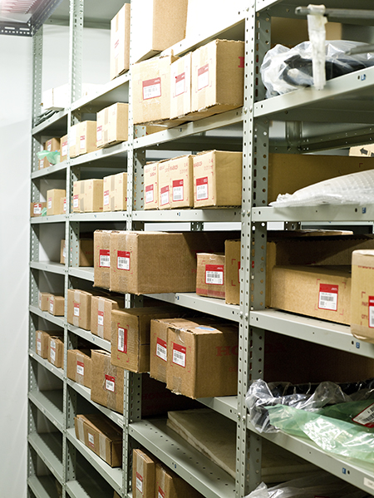  Jupiterimages/Photos.com/Thinkstock
- adequate shelving and storage appropriate to the materials involved
- braces as appropriate for the materials involved
Administrative Controls
- Provide instruction in handling of materials as appropriate for the materials involved.

- Ensure repetitive tasks are properly paced.

- Post important emergency telephone numbers and contacts.

- Post lockdown procedures.

- Post fire drill procedures.

- Establish handwashing practices.

- Ensure fire extinguishers are strategically located and marked.

- Provide a first aid kit and supplies, including an eyewash station and biohazard disposal.

- Ensure that the master control panel and panel breakers are properly labelled.

- Correctly place and maintain smoke detectors and heat sensors.

- Instruct students on proper lifting techniques.
Personal Protective Equipment (PPE)
- gloves
- apron
- steel-toed safety shoes or boots (CSA approved)

