CLUSTER | NAT: NATURAL RESOURCES
OCCUPATION | Wildlife
HAZARD CONTROLS | CONSUMABLE—AMMUNITION
Engineering Controls | 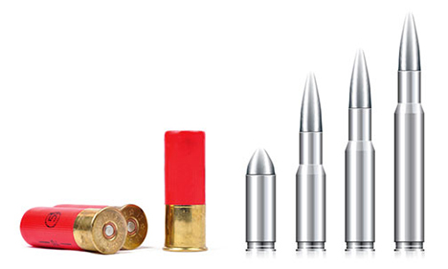  shotgun shells: © ruigsantos/shutterstock  bullets: iStockphoto/Thinkstock
- n/a
Administrative Controls
- Follow the school safety policy.

- Provide and document ongoing safety education and training, including mandatory equipment and tool orientation.

- Schedule work to avoid overcrowding.

- Establish handwashing practices.

- Provide a first aid kit and supplies, including an eyewash station and biohazard disposal.

- Always use safe handling techniques.

- Since each firearm has different safety mechanisms, individuals should use their firearms in accordance with manufacturers' specifications and should contact individual manufacturers to obtain further information.

- Read and follow manufacturer instructions, precautions, and directions for proper use, safety, maintenance, and cleaning.

- Provide initial training to include a thorough review of hazards and accidents associated with the task.

- Identify and establish regular sanitary and safe housekeeping practices.

- Develop and communicate safe work practices and procedures for hazardous work or situations.

- Ensure repetitive tasks are properly paced.

- Maintain class supervision at all times.

- Teach, transport, and store firearms in accordance with Canada’s Firearms Act (http://laws-lois.justice.gc.ca/eng/acts/F-11.6/). The RCMP website (http://www.rcmp-grc.gc.ca/cfp-pcaf/fs-fd/storage-entreposage-eng.htm) also provides information.
Personal Protective Equipment (PPE)
- latex gloves or hypoallergenic alternative
- hearing protection
- safety glasses or goggles
- proper footwear, depending on the task

