CLUSTER | NAT: NATURAL RESOURCES
OCCUPATION | Wildlife
HAZARD CONTROLS | TOOL—CAMP STOVE
Engineering Controls | 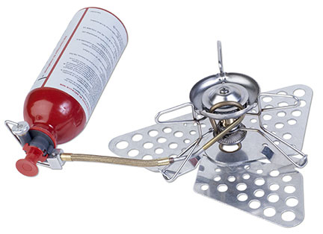  Hemera Technologies/PhotoObjects.net/Thinkstock
- n/a
Administrative Controls
- Use the camp stove in a properly ventilated area.

- Choose stove based on how and when you will use it (e.g., consider type of meal to be cooked, fuel, stability, ease of use, and maintenance).

- Follow the school safety policy.

- Provide and document ongoing safety education and training, including mandatory equipment and tool orientation.

- Tag and remove defective tools from service.

- Ensure the tool is appropriate for the work to be done.

- Schedule work to avoid overcrowding.

- Establish handwashing practices.

- Provide safe clearance for the tool

- Provide a first aid kit and supplies, including an eyewash station and biohazard disposal.

- Keep the manufacturer’s manual for the tool. Read and follow manufacturer instructions, precautions, and directions for proper use, safety, maintenance and cleaning.

- Provide initial training to include a thorough review of hazards and accidents associated with the job.

- Develop and communicate safe work practices and procedures for hazardous work or situations.

- Identify and secure materials that are less toxic and harmful to the student and environment.
Personal Protective Equipment (PPE)
- n/a

