Backs and Bums: Applying Basic Ergonomics eLearning Program

Name: | Date:
CTS Instructional Area:

The Backs and Bums: Applying Basic Ergonomics eLearning Program from Work Safe Alberta is an illustrative, interactive online training tool that discusses ergonomic issues.

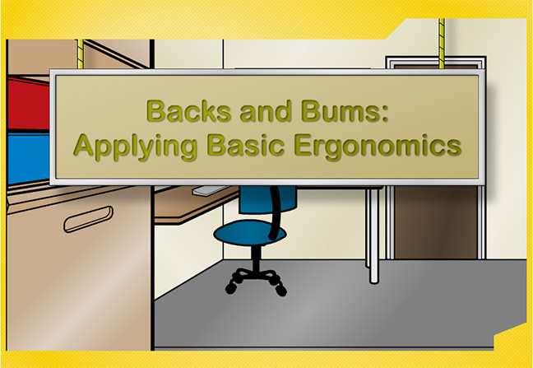
© 2011 Government of Alberta. Human Services. Work Safe Alberta

1. Click on the link to begin the eLearning program: http://work.alberta.ca/elearning/ergonomics/data/ergonomics.html

2. Use the table that follows to record a summary of your eLearning program. If you need more space, use additional paper.

eLearning Program Summary
Title:

