Basic Health and Safety eLearning Program

Name: | Date:
CTS Instructional Area:

The Basic Health and Safety eLearning Program from Work Safe Alberta is an illustrative, interactive online training tool that includes some practical tools that can help you follow the health and safety laws in Alberta.

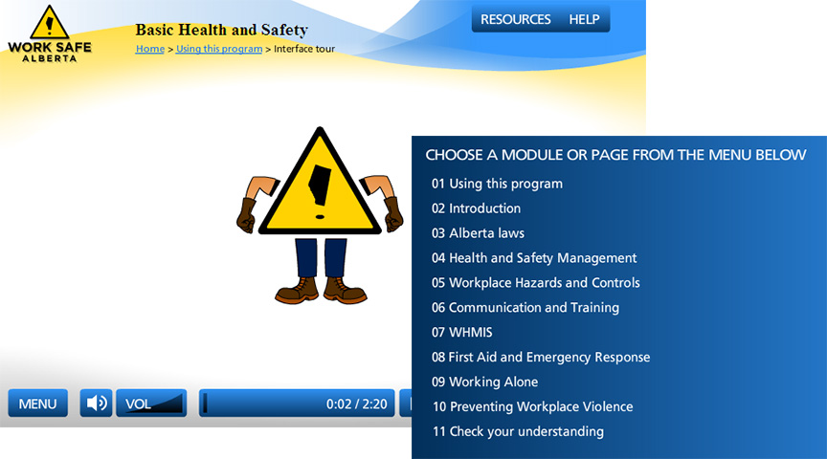
© 2011 Government of Alberta. Human Services. Work Safe Alberta

1. Click on the link to begin the eLearning program: http://work.alberta.ca/elearning/health/index.html

2. Use the table that follows to record a summary of your eLearning program. If you need more space, use additional paper.

eLearning Program Summary
Title:

