Health and Safety Management Systems eLearning Program

Name: | Date:
CTS Instructional Area:

The Putting It All Together: Your Health and Safety Management System eLearning Program from Work Safe Alberta is an illustrative, interactive online training tool that examines the basic elements of an effective health and safety management system for the workplace.

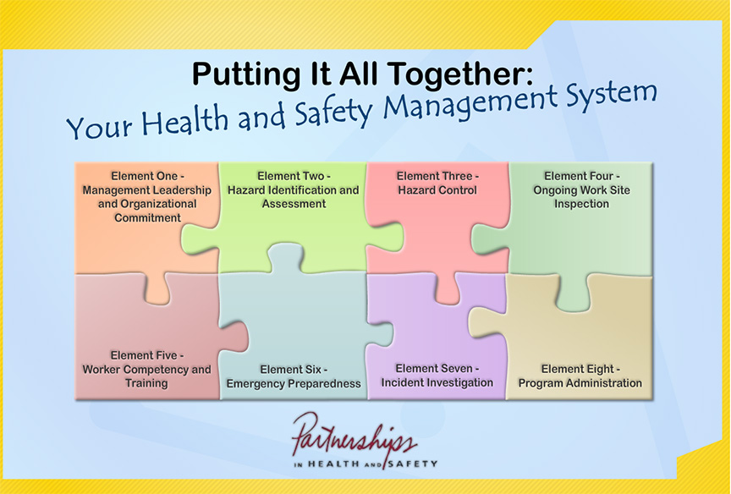
© 2011 Government of Alberta. Human Services. Work Safe Alberta

1. Click on the link to begin the eLearning program: http://humanservices.alberta.ca/elearning/HealthAndSafety/data/HealthAndSafety.html

2. Use the table that follows to record a summary of your eLearning program. If you need more space, use additional paper.

eLearning Program Summary
Title:

