Books and Me

Student Name | Date

I like books: a little a lot!

My favourite books are:

Where I like to read:
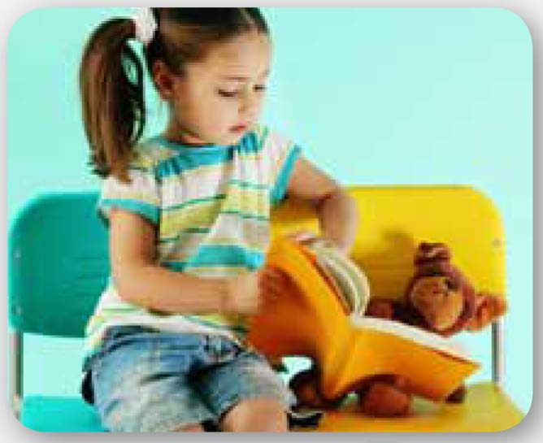  on a chair | 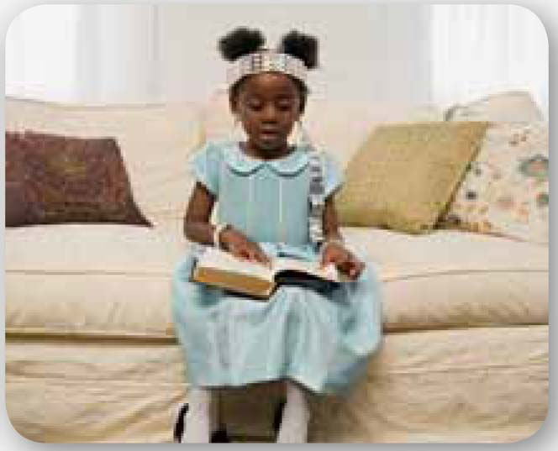  on the couch | 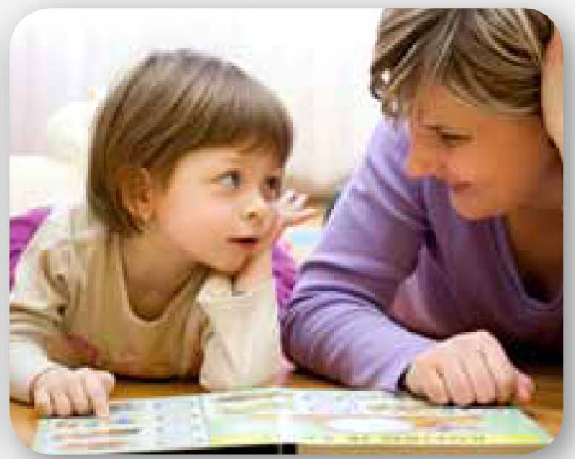  on the floor
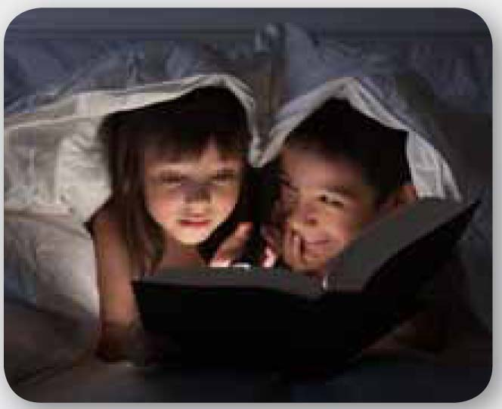  in bed | 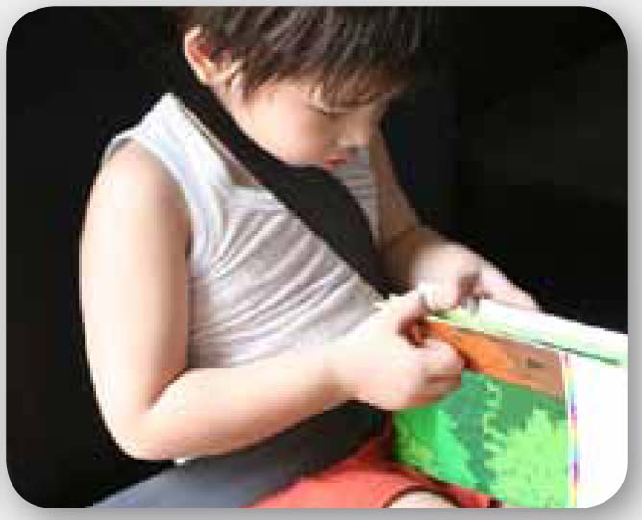  in the car |   on a tablet, my phone or  on my computer

Who I like to read with:

I like to read because

Books I want to read are

