Examples of Group Assessment

1. These 3-D objects were sorted using a two attribute rule. Clearly explain the rule they were sorted by.

Follows the Rule Does Not Follow the Rule
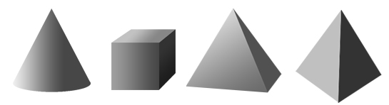
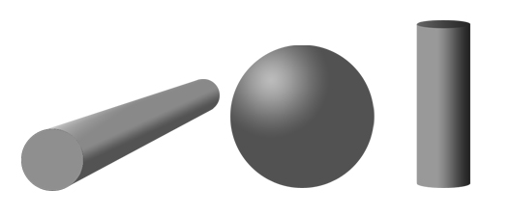

Rule:

2. Sort the following by printing an "R" on the 3-D objects that follow the rule and an "X" on those that do not.
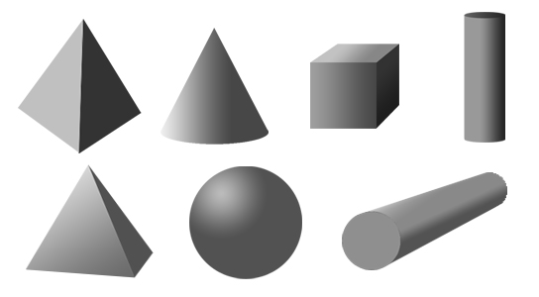

Explain why you sorted each shape into the group that you did.

3. Mark a "C" for cube on all the members of the cube family below. Then write three things that they all have that let you know they belong to the cube family.
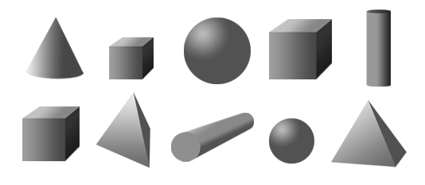

Three reasons I know that these 3-D objects belong to the cube family are:

a.

b.

c.

4. Circle all the members of the cylinder family in the 3-D objects below.
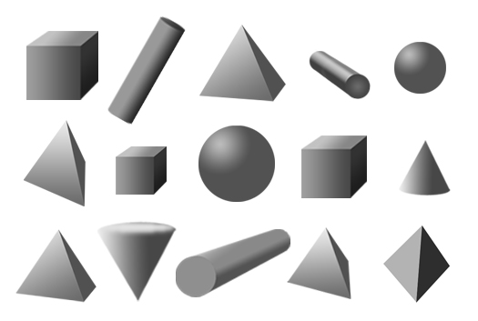

Two reasons that I know these 3-D objects belong to the cylinder family are:

a.

b.

5. Circle all the members of the pyramid family in the 3-D objects below.
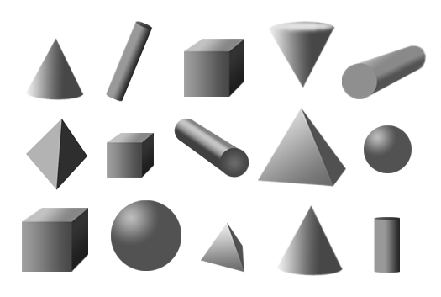

Two reasons that I know these 3-D objects belong to the pyramid family are:

a.

b.

Whole Class/Group Assessment Key

1. These 3-D objects were sorted using a two attribute rule. Clearly explain the rule they were sorted by.

Follows the Rule Does Not Follow the Rule

Rule: These objects all can slide and have at least one point or vertex.

2. Sort the following by printing an "R" on the 3-D objects that follow the rule and an "X" on those that do not.

Explain why you sorted each shape into the group that you did.

The sphere can roll, but does not have any faces, so it did not belong in the group that
followed the rule.
The 2 cylinders have 2 round faces and can roll, so they belonged in that group that follows
the rule.
The pyramids have no round faces and cannot roll, so they did not belong in the group that
follows the rule.
The cube has no round faces and cannot roll, so it does not belong in the group that follows
the rule.
The cone has one round face and can roll, so it belongs in the group that follows the rule.
3. Mark a "C" for cube on all the members of the cube family below. Then write three things that they all have that let you know they belong to the cube family.

Three reasons I know that these 3-D objects belong to the cube family are:

a. They have six square faces or all the faces are square.

b. All the edges are straight line edges.

c. There are more than five or there are eight vertices or points.

4. Circle all the members of the cylinder family in the 3-D objects below.

Two reasons that I know these 3-D objects belong to the cylinder family are:

a. They have two round circular faces.

b. They have a curved or rounded surface and can roll.

5. Circle all the members of the pyramid family in the 3-D objects below.

Two reasons that I know these 3-D objects belong to the pyramid family are:

a. They have one vertex above the center of the base or they have 4 or 5 vertices/points
or they have a square or triangular face for a base.

b. They have some triangular faces. (Students may or may not state that there are 4 of these.)

