Sample Activity 2: Identify Errors in Given Increasing Pattern
(Specific Outcome 2, Achievement Indicator c)

Error Hunt

Construct some increasing patterns with concrete materials that have an error. Ask the students to stand when they think they have identified an error as you uncover progressive steps in the pattern. Have the students describe where the error lies and how they knew it was an error. Then have them tell and show how to correct it. Vary the manipulative with which the patterns are constructed. This process is very teacher-centred at this stage. As soon as students have experienced a few of these patterns, ask the students to make one or more growing patterns from a manipulative in the classroom. Ask them to include an error, but to make sure there is enough information included in the steps so that others will be able to see what the pattern should have been and how to correct it. Ask the students to make a correct copy of the pattern as well. These can be photographed or scanned and put on the computer so that they can be accessed by the entire class. Alternatively, this project can be at an activity centre so only a few students each day make their increasing patterns and a version with an error. The other students visit it during the day and at the end of the day discuss the error and how it could be corrected.

Here are some possible patterns with errors that you could show students. Ask them to find the errors in the following patterns and be ready to correct them. Also, ask them to explain how they knew there was an error and how they knew what the correct steps were.

1. ■ ■■ ■■■ ■■■■■ ■■■■■■

2.   |  |  | 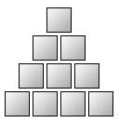
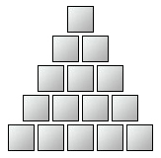 |  | 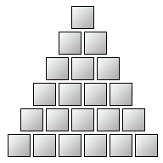

3. ■■■ ■■■■■ ■■■■■■■ ■■■■■■■■■

4.

5.

6.
 |  |  | 

7. 2, 4, 6, 8, 10, 14, 16, 18, 20

8. 1, 2, 4, 8, 32, 64

9. 1, 2, 4, 7, 11, 16, 29

10. 5, 10, 15, 20, 30, 35, 40

11. 10, 20, 30, 50, 60, 70

Ongoing assessment:

Be sure all students are asked to share their solutions when the above questions done are in class. When the students create their own, observe whether they accurately create increasing patterns and which kinds they attempt, as well as whether they understand these patterns well enough to make their error with sufficient information for detection and correction. You will want to check these before using them as a test for students. Otherwise, you will have to rely on students to tell the creators that their pattern cannot be detected and corrected because it does not contain enough information. Sometimes feedback from the other students is quite valuable, but you also do not want this activity to confuse them.

