Examples of Group Assessment
Linear Measure

Name: ___________________ Date: __________________

You and a group of friends were arguing about the length of some of your sports equipment. You were planning ways to check who was right. What ideas would you give the group about how to measure each of the things you were comparing?

1. One item you wanted to check was the length of your ice hockey sticks. Which of the following nonstandard units would you use to measure them and why?
a. Unifix cubes b. base ten rods c. straws

Why?

2. You also wanted to measure the length of your floor hockey sticks. Which one of the nonstandard units would you chose and why?
a. centicubes b. Unifix c. stir sticks

Why?

3. You wanted to measure the distances around a basketball and around a soccer ball so you could find out how much bigger the basketball is than the soccer ball. How would you measure the balls?

4. When you measured the distance across a Frisbee, it was 11 Unifix cubes wide. If you remeasured the width using centicubes, how many centicubes wide do you predict it would be and how did you make your prediction?

5. a. You only have one paperclip in your pocket and you want to measure the width of this puck. How would you do it?

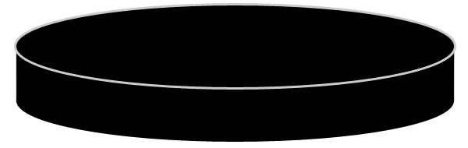

b. How can you measure carefully so you will have the least possible measurement error?

c. How would you measure the width of this puck if you had a box of paperclips?

6. Your coach asked you all to bring to the game Thanksgiving weekend a can of food to give to the food bank. You wanted to find out whose can was tallest and whose can was biggest around. Before you measure your can, make your estimates of the distance around and height. Use the paperclips the teacher put out to make your measurements. Print the number that is on the can here:
Can number: _________

Height: estimate: _________ paperclips actual measure: _________ paperclips

Distance Around: estimate: _________ paperclips actual measure: ________ paperclips
7. When you were skating down the ice, your path looked like the line below. Your friend's path running down the soccer field is below that. First print whose path you predict is longer. Measure each path. Whose path was longer and by how much? You may use any of the materials the teacher has provided.

Path down the ice in hockey: This path is ______ _______________________ long.

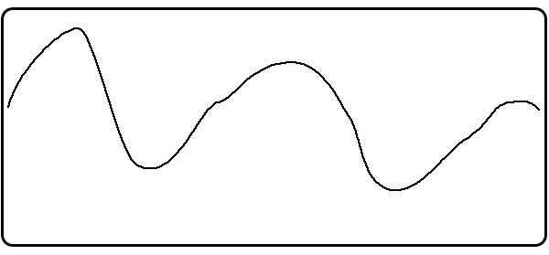

Path down the field in soccer: This path is ______ _______________________ long.

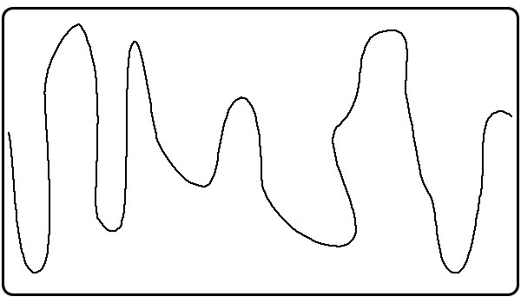

The path that is longer is the ___________________ path by _______ _________________ .

8. Measure the diagonal of this paper from the upper left corner to the bottom right corner. Put a green dot on the upper left corner and a red dot on the lower left corner.
It is ____________ ___________________ long.
how many units
Now turn the page sideways and estimate the length of the diagonal starting at the green dot and going to the red dot.
I estimate it is _________ _____________________ long.

I think I am right because

9. Measure and order the following objects at one of the measurement stations in the classroom. You may use any of the nonstandard units found there, but print which ones you used.

a. The height of the box of macaroni is __________ _______________________ tall.
how many units

The height of the box of crackers is __________ _______________________ tall.
how many units

The height of the box of cereal is __________ _______________________ tall.
how many units

Order these objects from tallest to shortest:

______________________ , ________________________, _____________________

b. The length of the small can of tomato paste is __________ ___________________ long.
how many units

The length of the can of beans is __________ ___________________ long.
how many units

The length of the can of juice is __________ ___________________ long.
how many units

Order these objects from smallest to largest:

______________________ , ________________________, _____________________

c. The distance around the small can of tomato paste is _________ ____________ around.
how many units

The distance around the can of beans is __________ _____________ around.
how many units

The distance around the can of juice is _________ _____________ around.
how many units

Order these objects from largest to smallest:

______________________ , ________________________, _____________________

Measure of Mass/Weight and Linear

Name: ___________________ Date: __________________

Your twin cousins asked you to help them organize their room. They have some shelves on which to put their toys. They want to put the lightest toys on the top shelf and organize the rest by weight so that the heaviest things are on the bottom shelf. Your cousins have made an equal arm balance scale. They found some things in the garage, their room and their parents' computer room to use for nonstandard units: paperclips, washers, nails, marbles, pennies, blocks and golf balls.

Please help them by answering the questions below.

1. The twins wondered which one of these nonstandard units to use to weigh their

a. little metal cars

paperclips or small nails? They should use the ____________________________________ .

Why? ____________________________________________________________________ .

b. hockey cards

golf balls or pennies? They should use the ________________________________________

Why? ____________________________________________________________________

c. rock collection

marbles or golf balls? They should use the ________________________________________

Why? ____________________________________________________________________

d. plastic whistle

paperclips or pennies? They should use the ________________________________________

Why? ____________________________________________________________________
2. How many marbles do you estimate would have the same weight as a baseball glove?

I estimate the baseball glove would have the same weight as _________ marbles.

You couldn't find the marbles and so decided to use pennies instead. Do you estimate it would take more, fewer or the same number of pennies as marbles to equal the baseball glove?

I estimate it will take ______________________________________ pennies than/as marbles to equal the weight of the baseball glove.

How many pennies? _____________

Explain why you think so.

3. When it is your turn and no other student is there, go to a measurement station. Estimate the weight of the action figure there in the nonstandard units of your choice. Record your estimate and print the units used. Circle the letter of the station where you worked. Then weigh the action figure and record the actual weight and the units.

I was at station A, B, C or D.

My estimate: ______________ _________________________.
how many units

My action figure actually weighed _____________ ______________________ .
how many units

4. a. While at the measurement station, weigh the following three items found there and put them in order from the heaviest to the lightest:

 | plastic boat | rubber ball | metal car
Estimate with units
Actual with units

My order is
First: _____________________,
Second: __________________,
Third: ____________________.

b. Weigh the second collection and order them from the lightest to the heaviest.

 | eraser | scissors | roll of masking tape
Estimate with units
Actual with units

My order is
First: ,
Second: ,
Third: .

5. As the students placed things on the shelves, they needed to know how much room to leave for things, so they measured how long items were and marked the amount of room with a piece of tape on the shelf. They didn’t have a ruler, so they used the things they had gathered from home or things they borrowed from their classroom. Here is a picture of the toy car they were placing on the shelf.

What nonstandard unit would you use to measure it and why?

My estimate is ____________ ______________________________ .

Actual measure: _____________ ____________________________ .

Then the students decided it would be better if the car faced the other way, as shown below.



What length of shelf space do you predict it will need facing this way?

How did you figure this out?

