Sample Activity 1: Number Rolls

What Is a Number Roll?
Number Rolls are simply strips of paper with the counting sequence written vertically, that are taped to a straw or a toilet roll at the top edge and then rolled up so that more numbers can be added.
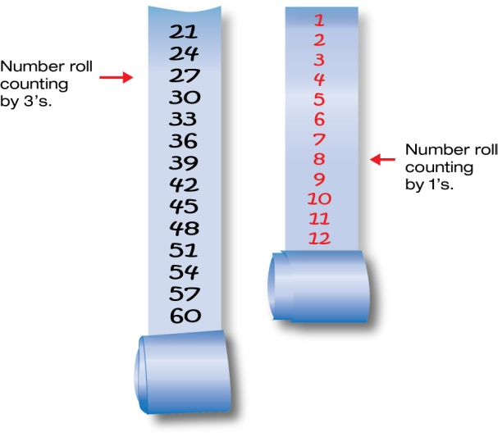

Creating Number Rolls
If number rolls are made on strips of grid paper, they can also be used to measure and compare lists of numbers. One way to do this is to use a three-column format in a word processing document and make tables, 3 columns wide and 20 rows long, in each column. After these pages are photocopied they can be cut into three strips each. Students glue or tape strips onto the end of their number roll as they need them.

Using Number Rolls
Students can continue their number roll over the course of the whole school year, learning the pattern of digits in its increasing complexity, in order to gain greater and greater number sense. Some students are very motivated to do this, in order to see how high they can go. This generates lots of discussion about large numbers. It also shows how each new power of 10 is exponentially larger that the last. Encourage predictions and observations about patterns in the numbers and about magnitude of numbers. How long will it take to get to 2000? 3000? 10 000? Students often enjoy unrolling their long strips in a hallway or the gym. This helps them gain a visual and experiential sense of the magnitude of large numbers.

Initially, number rolls are a great way to make sure that all students can count and write numbers correctly over 100. In the beginning, number rolls are good as a whole class activity. Students can continue to work on number rolls as an activity for fast finishers or a choice or centre activity.

Variations of Number Roll Activities
Some variations on the basic number roll activity include having groups of students work together in a 20-minute window to see how far they can get along the number sequence by collaborating. This works best with 11-inch strips of pre-prepared grid paper. Students divide up the work in a way that shows whether or not they understand the patterns in how the numbers are written. At the end of the 20 minutes, the whole class can discuss its strategies, including why they worked and which strategies were most efficient.

A variation for students who show a good understanding of numbers to 1000 is to use a
4-column-wide-grid and have them start at 1000.

