Sample Activity 2: Open and Closed Sorts

Provide students with a variety of 2-D shapes, including shapes that are polygons (regular and irregular as well as triangles of all kinds) and those that are not polygons. Use BLM 1–6 on pages 2–7.

Look For …
Do students:
- sort 2-D shapes into two or more groups and describe the sorting rule?
- sort 2-D shapes into two or more groups in a different way and describe the sorting rule?
- critique sorting rules created by other students?
- sort 2-D shapes into given categories and explain their thinking?

Open Sort
Instruct students to sort the 2-D shapes into groups and describe the sorting rule. Then, have students sort the shapes in a different way and describe the sorting rule.

Closed Sort
Provide students with the categories into which they are to sort the 2-D shapes; e.g., polygons and not polygons, regular polygons and irregular polygons. Have students sort the 2-D shapes into the given categories and explain their reasoning.

2-D Shapes – BLM 1
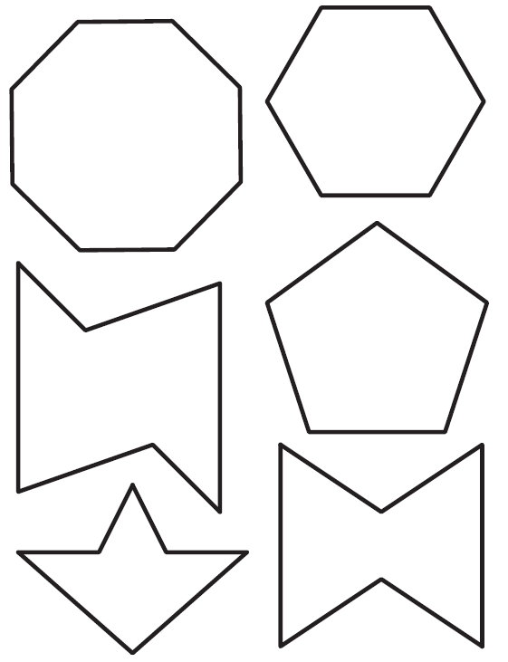

2-D Shapes – BLM 2
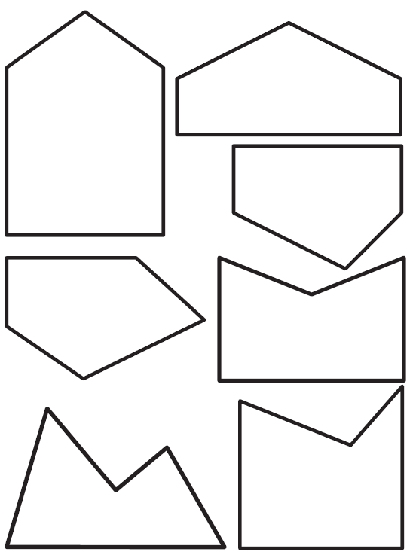

2-D Shapes – BLM 3
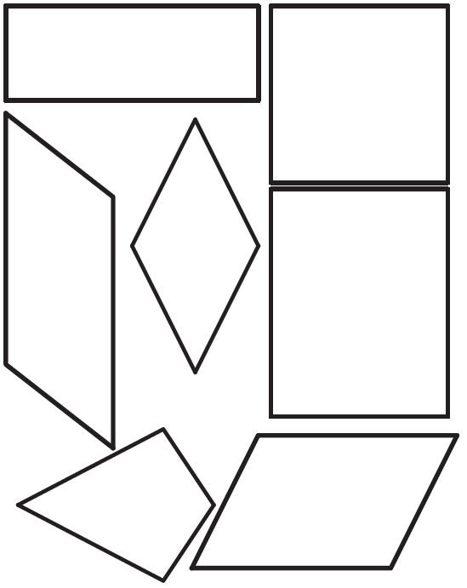

2-D Shapes – BLM 4
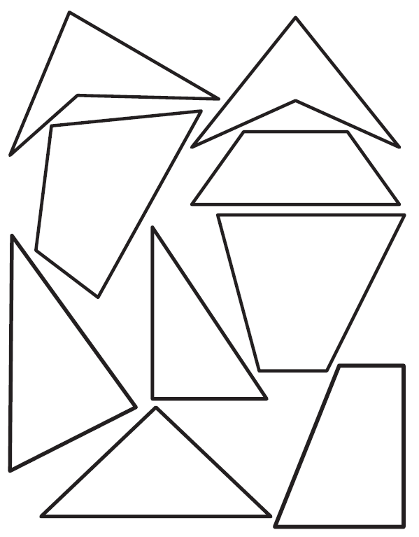

2-D Shapes – BLM 5
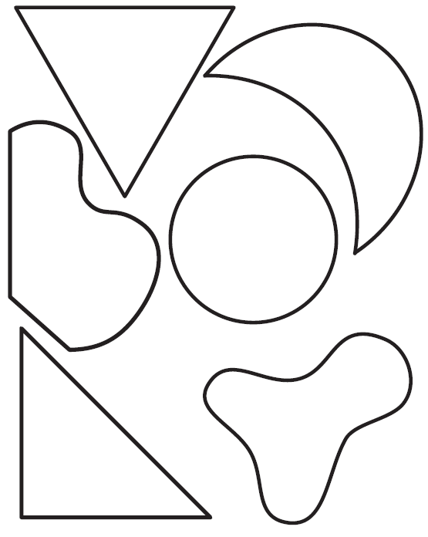

2-D Shapes – BLM 6
