Sample Activity 5: Naming Amounts Greater than One in Different Ways

Provide students with concrete materials, such as pattern blocks, square tiles, fraction circles and counters. Also provide them with square dot paper and triangular dot paper. (Use BLM 1 and 2 on pages 2 and 3.)

1. Naming a Mixed Number as an Improper Fraction

Look For …
Do students:
- translate a given improper fraction or mixed number between concrete, pictorial and symbolic forms?
- use a variety of ways to express an improper fraction as a mixed number?
- use a variety of ways to express a mixed number as an improper fraction?
- clearly communicate the connections between mixed numbers and improper fractions using correct mathematical language?

Give students a mixed number, such as .
a. Have them represent the mixed number using concrete materials and draw a corresponding diagram.
b. Tell them to find an improper fraction that represents the same amount and to justify their answer.

2. Naming an Improper Fraction as a Mixed Number
Give students an improper fraction, such as .
a. Have them represent the improper fraction using concrete materials and draw a corresponding diagram.
b. Tell them to find a mixed number that represents the same amount and justify their answer
(Van de Walle and Lovin 2006, p. 69).
2-cm square grid – BLM 1
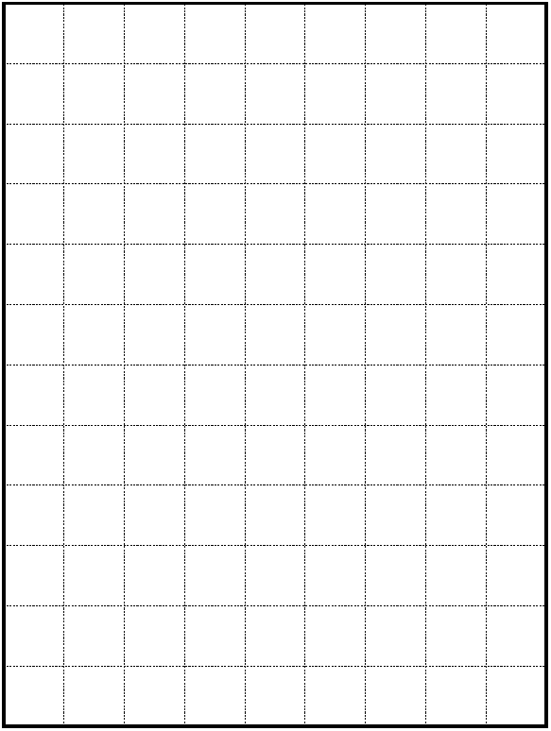

Isometric grid paper – BLM 2
