Strategies for Reinforcing and Extending Learning

Consider strategies, such as the following.
- Provide tips for parents on working with area at home or in the community. For example:
- Find the area of a lawn to determine how much sod is needed. Include shapes that are triangular and circular.
- Find the area of a circular tabletop that will be covered with glass.
- Find the total area of a quilt that is being made. Each congruent piece of material in the quilt will be shaped like parallelograms or squished rectangles.

- Use the Geometer's Sketchpad to draw circles and explore the relationships among radius, diameter and the quotient of the area and the radius squared. Explore the effect on the area of the circle when the radius is doubled or tripled. Compare it to the effect on the circumference of the circle (Bennett 1999, pp. 117–129).

- Use the Geometer's Sketchpad to draw parallelograms and triangles and explore the relationship between the base and the height as the area changes, or explore the relationship between the base and the area as the height changes.

- Use the Geometer's Sketchpad to construct meaning for the formulas describing the area of parallelograms and triangles. Students can maintain the same base and height for a parallelogram and convert it into a rectangle. They may also draw a triangle, copy it, turn it 180º and attach the two triangles together to make a parallelogram.

- Read the book Sir Cumference and the Isle of Immeter (Neuschwander 2007) to students and have them predict the answers to the riddles that appear in the story. Encourage students to act out the story by cutting the sectors in a circle to create a rectangle as described in the story. Provide time for students to relate the circumference of a circle to its area by using diagrams and number sentences. The number sentences include the following:
C = 2r, ½ C = r, A = r x r, A = r².

- Have students explore what shape would provide the maximum area for a given perimeter. Present students with the following problem:
You have 30 m of fencing to make the largest possible pen for your pet. What shape would you make the pen? Explain.
Provide students with string so that they can act out the problem. They could use 30 cm of string to represent the 30 m of fencing and place the various created shapes on centimetre grid paper to determine which shape would provide the greatest area.

- Provide students with a variety of problems in which two of the following three measures are provided and the student must find the third measure:
- radius, diameter, area
- base, height, area.

- Have students create problems about everyday contexts for areas of parallelograms, triangles and circles.

- Challenge students to compare the graph for the circumference of circles (C = 3.14 d) with the graph for the area of circles (A = r²). Encourage them to discuss the similarities and differences between the two graphs.

- Provide students with small circular objects to trace (e.g., jar lids, cups), string, centimetre grid paper and tape. Have students trace around one circular object, use centimetre grid paper to measure the area of the circle and record the area inside the circle. Have them use string to measure the circumference of the circle. Instruct them to cut another piece of string that is double the length of the circumference and form another circle, taping the string in place. Have students predict if the area of the new circle is twice the area of the original circle and then measure the area using the centimetre grid paper. Discuss the relationship between the circumferences and the areas of the two circles, and have students write a sentence that describes this relationship.
From About Teaching Mathematics, A K–8 Resource, 2nd Edition by Marilyn Burns. Page 57. Copyright © 2000 by Math Solutions Publications. Reproduced by permission. All rights reserved.

- Have students discover Pick's Rule (A = 1/2 b + i – 1) by constructing various polygons on geoboards and geopaper and examining the patterns formed. Have them record in a chart the number of dots on the boundary of the polygon (b), the number of dots inside the polygon (i) and the number of squares for the area (A) of the polygon. For example:
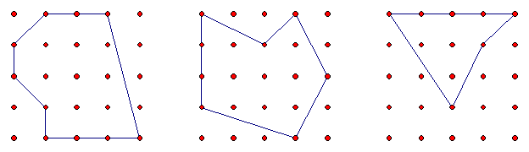
Polygon #1 Polygon #2 Polygon #3

Polygon | 1 | 2 | 3
Number of dots on the boundary of  the polygon | 10 | 8 | 7
Number of dots inside the polygon | 8 | 8 | 3
Area of the polygon (square units) | 12 | 11 | 5.5

Have students examine the patterns in the table to develop a formula that can be used to find the area of any polygon, given the number of dots on the boundary and the number of dots inside the polygon.

Encourage students to create other polygons and apply their formula to finding the areas of these polygons; e.g., Find the area of the following
polygon, using Pick's Rule.
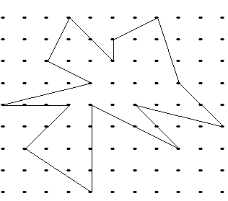

Adapted from Alberta Education, Measurement: Activities to Develop Understanding (unpublished workshop handout) (Edmonton, AB: Alberta Education, 2005), pp. 79–85.

