Examples of Group Assessment

Provide students with graph paper.

- a) Create a table of values for the linear relation n → 3n – 4.
b) Draw a graph for the table of values that you created.

- Create a problem or draw diagrams to represent each of the following linear relations:
a) N → 3N
b) N → 3N + 1

- Sam's Steak House has hexagonal tables that each seat 6 people. If you push 2 tables together, 10 people can be seated. If you push 3 tables together, 14 people can be seated.
- Write a general rule (linear relation) that can be used to calculate the number of people that can be seated given any number of tables put end-to-end. Explain your thinking.
- Use your general rule to find how many people can be seated if 30 tables are put end-to-end. Show your work.

- Which of the following linear relations best describes the graph below? Explain your thinking.

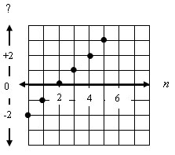

A. n → n – 2 B. n → 2n – 2
C. n → 2 – n D. n → 2 – 2n

- Use the following graph to answer the questions. Assume that Peter and Flopsy start the race at the same place.

Bunny Race
Legend

Peter Rabbit

Flopsy Rabbit
600
metres
40
20
0
2
4
6
8
seconds

- If the distance for the race is 60 m, who wins the race and by how much?
- How far from the start did Peter overtake Flopsy?
- How many seconds from the start did Peter overtake Flopsy?
- Who was ahead after 8 seconds? By how much?
- Provide a reason why Peter had a delayed start to the race.
- Create another question that can be answered from this graph.

