Sample Activity 1: The Game of Sticks and Stones

This activity adapted from National Council of Teachers of Mathematics, "Sticks and Stones," NCTM Illuminations, 2000–2008, http://illuminations.nctm.org/LessonDetail.aspx?ID=L585 (Accessed April 2008). Used with permission.

- This game is based on the Apache game "Throw Sticks," which was played at celebrations.

Look For …
Do students:
- use correct vocabulary such as more likely, less likely, probable, outcomes and tree diagram?
- calculate the possible outcomes of independent events in more than one way; e.g., tree diagrams, tables?
- demonstrate flexibility in using a variety of manipulatives to solve problems involving probability?

- Students will collect data and investigate the various probabilities of throwing the sticks.
- To play the game, students throw three sticks, each decorated on one side only; the other side should be blank. Students will use these sticks to determine how far they move.
- To create the game board, arrange 40 round markers in a circle, preferably divided into four groups of 10. As an alternative you can use a game board, which consists of 10 squares on each side of the board.

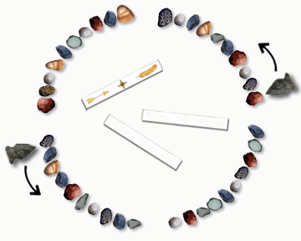

Rules of the Game:

- Object of the Game: Be the first player to move your piece around the board past your starting point.
- Set-Up: Each student should place a marker on opposite sides of the circle (game board). The area inside the circle (the middle of the board) is used for throwing the sticks.
- Play: Determine which player will go first. Player 1 throws the three sticks into the centre of the circle and moves his or her piece according to the results (shown in the chart below). Player 2 then throws the sticks and moves accordingly. Play continues with players alternating turns.
- Special Rule: If one player's marker lands on or passes another player's, the player passed over must move his or her piece back to the starting point.

Moves

3 Decorated Sides 10 spaces

3 Blank Sides 5 spaces

2 Decorated, 1 Blank 3 spaces

2 Blank, 1 Decorated 1 space

Instruction suggestions:

- Students will need markers, a Monopoly game board (or 40 round markers to simulate the original game with stones), and popsicle sticks.
- Have students decorate three popsicle sticks on one side only, using different colours for each stick.
- Pair students together, and let them play the game once, for fun.
- Before playing a second time, have students make a list of all throws that are possible. The possible outcomes could be organized as follows:
– 3 Decorated, 0 Blank
– 2 Decorated, 1 Blank
– 1 Decorated, 2 Blank
– 0 Decorated, 3 Blank
- During the second game, have students keep track of how often each throw occurs.
- After tallying the total of each type of throw, have students draw a graph that shows the possible throws on the horizontal axis and the number of occurrences on the vertical axis. Gather data from 4–6 pairs of students to give a larger sample size (this should yield experimental results closer to the theoretical possibilities). A completed graph could look something like this.

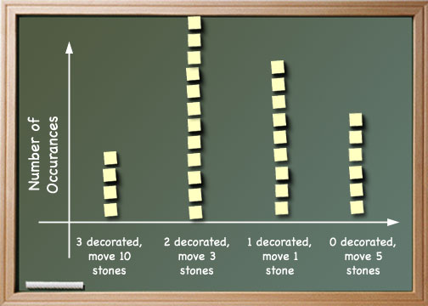

Facilitate a discussion about what the graph tells us. You may want to ask: Which type of throw is most likely to occur? Least likely? Is this what you would expect to happen?

- Determine the probability of each outcome using the table.

