Sample Activity 1: Representing Percents

This activity adapted from National Council of Teachers of Mathematics, "Grid and Percent It," NCTM Illuminations, 2000–2008, http://illuminations.nctm.org/LessonDetail.aspx?ID=L249 (Accessed April 2008).
Used with permission.

- Distribute a grid worksheet to all students (blackline master provided on the following page).

- Ask the students to represent various percents on these grids—be sure to include whole number percents such as 10%, 39% and 84% as well as decimals and fractions such as 28.5% and 76%.

Look For …
Do students:
- recognize that 100% is represented by one whole square (10 × 10 grid) and that one percent is represented by one small square, or one hundredth of a unit square?
- recognize that a percent between 0 and 1 is represented within one small square?
- recognize that a percent greater than 100 is represented by more than one whole square?
- Display some shaded grids on the overhead, and have the students determine the percent for a shaded amount (see the examples below). Again, be sure to include decimals and fractions.

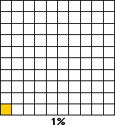 | 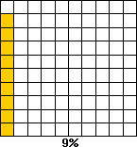 | 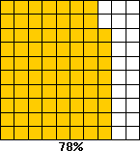

- Have the students represent percents less than 1 percent and greater than 100 percent. The figures below show that when of a square is shaded, this represents %, and when one entire unit square plus another 34 small squares are shaded, this represents 134%.

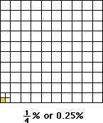 | 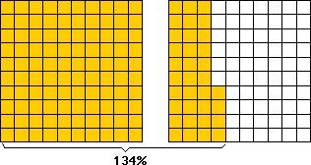

- Have the students represent %, %, 116%, 232% and others on the grids and provide explanations of what each representation means.

