Examples of One-On-One Assessment

Activity 1: What fraction of the square shown below is shaded? Record your answer in decimal, fraction and percent forms and provide an explanation. Points P and Q are midway along their sides.
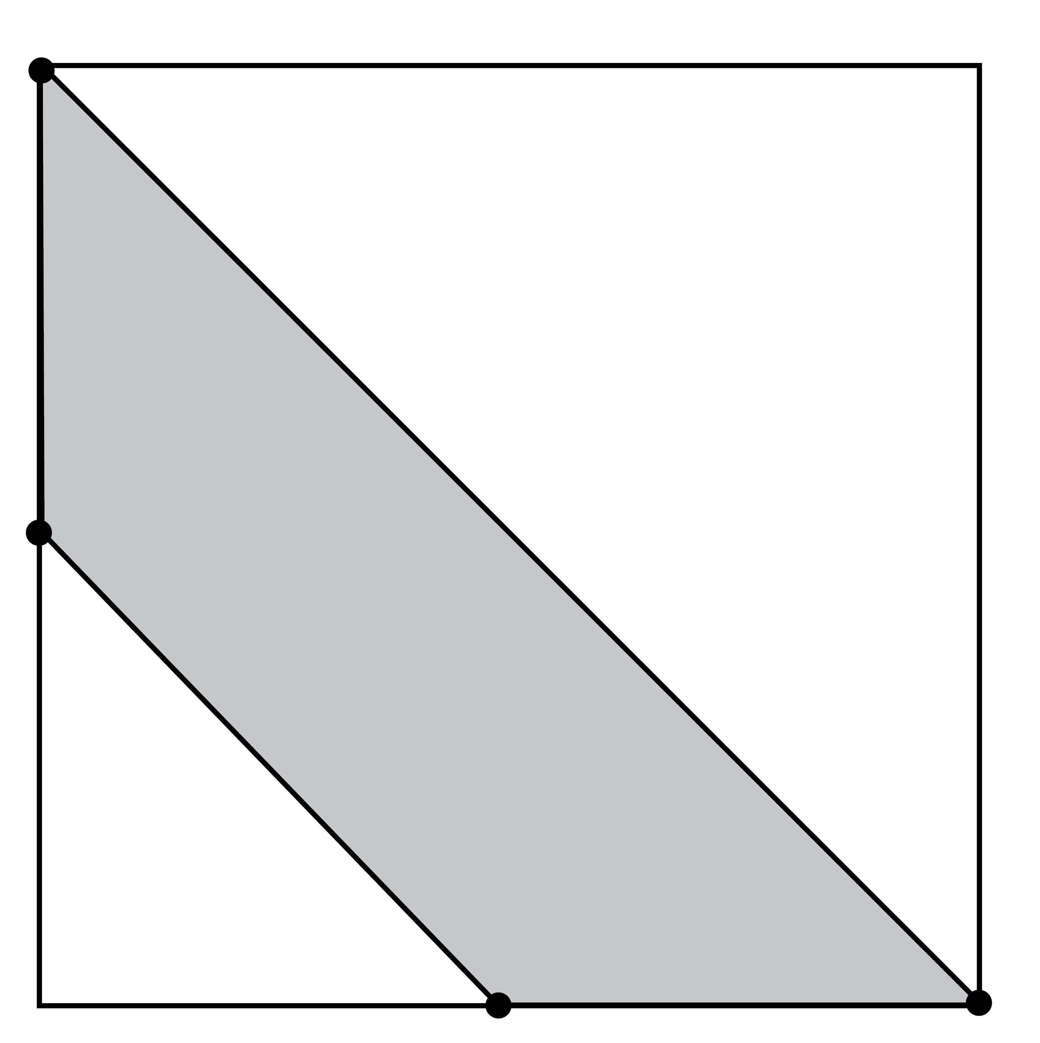

P

Q

This activity adapted with permission from Grayson H. Wheatley and George E. Abshire, Developing Mathematical Fluency: Activities for Grades 5–8 (Tallahassee, FL: Mathematics Learning, 2002), p. 53. www.mathematicslearning.org

Activity 2: Solve the following problems.

- A recent article in the Calgary Herald stated that Peter Munk, an 80-year-old billionaire, made rather a lot of money in 2006 when he sold one of his companies for $4.8 billion, tripling his investment.

a. Explain the meaning of "tripling" his investment.
b. Find the value of his original investment.

Justify your solutions with a drawing and an explanation.

- The same article stated that when Mr. Munk first got into the gold business 25 years ago, his business was worth $40 million and the price of gold was $220 an ounce. Now the price of gold is around $950 an ounce and his business has a value of more than $40 billion. Calculate the percent increase of:

a. the price of gold, and
b. the net worth of Mr. Munk's company.

Be sure to justify your calculations with diagrams and an explanation.
Activity 3: Parts of the following figures are shaded. Express these shaded parts as fractions, decimals and percents.

a.

b.

c.

d.

Activity 4: You are travelling in British Columbia with your family. The family stops at a restaurant for lunch and orders pizza. They ordered two large pizzas: one house special and one pepperoni and mushroom. Mom and Dad order coffee. You and your brother order a pop. The waitress brought your drinks, including a glass of water for each person, right away. The pizzas were ready soon afterward, and she brought them right over, with a stack of extra napkins. The bill was $34.80 before tax. Answer the following questions:

- What percent tip would you give and what amount would it be?
- In British Columbia, you must pay 7% PST and 5% GST. What was the final total of the bill for your family's lunch? (PST is calculated first and then the GST).

This activity adapted from Burns, Marilyn. About Teaching Mathematics: A K–8 Resource, Second Edition, p. 250. Copyright © 2000 by Math Solutions Publications. Adapted by permission. All rights reserved. (Note: This title is now in its third edition, copyright © 2007.)
Activity 5: Have the students solve the following problems and provide explanations and diagrams with their solutions.

- Boss Middle School has an enrollment of 575 students. This represents 320 families who attend the school. At last night's PTA meeting, 70 percent of the families were represented. How many families were represented at the meeting?
- Margaret has read 40 out of the 320 pages from her latest book club read. What percentage of the book has she read?
- In Hazard County, 38 percent or 57 of the schools have a pupil-teacher ratio that meets or exceeds the requirements set out by the Department of Education in that area. How many schools are in Hazard County?

These problems adapted from John A. Van de Walle, LouAnn H. Lovin, Teaching Student-Centered Mathematics: Grades 5–8, 1e (p. 121). Published by Allyn and Bacon, Boston, MA. Copyright © 2006 by Pearson Education. Reprinted by permission of the publisher. AND from National Council of Teachers of Mathematics, "Grid and Percent It," NCTM Illuminations, 2000–2008, http://illuminations.nctm.org/LessonDetail.aspx?ID=L249 (Accessed April 2008). Used with permission.

