Ways to Assess and Build on Prior Knowledge

Activity 1: Do triangles with the same base have the same area? Give reasons for your solution, including diagrams.

Activity 2: The formula for finding the area of a rectangle and the area of a parallelogram is the same. What relationship is there between these two polygons that allows this to happen? Give reasons for your explanation, including diagrams.

Activity 3: Estimation Quickie: Select a single object such as a box, a watermelon, a jar or even the principal. Each day, select a different attribute or dimension to estimate. For example, students can estimate the length, weight or circumference around the middle section of a watermelon.

Adapted from John A. Van de Walle, LouAnn H. Lovin, Teaching Student-Centered Mathematics: Grades 5–8, 1e (p. 235). Published by Allyn and Bacon, Boston, MA. Copyright © 2006 by Pearson Education. Reprinted by permission of the publisher.

Activity 4: This activity compares the length of the room using non-standard units.

This activity adapted from John A. Van de Walle, LouAnn H. Lovin, Teaching Student-Centered Mathematics: Grades 5–8, 1e (p. 234). Published by Allyn and Bacon, Boston, MA. Copyright © 2006 by Pearson Education. Reprinted by permission of the publisher.

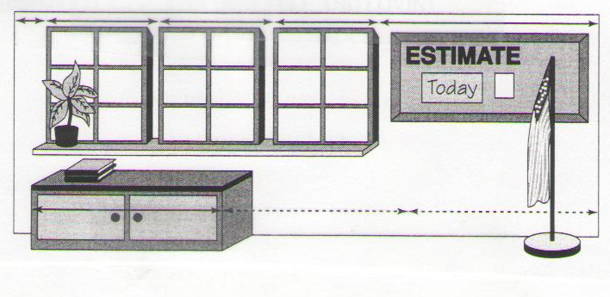

Estimate the length of the room pictured above in terms of:

- windows
- bulletin board
- cabinet

Note: The length of the room is approximately 3 cabinets plus a little more.

Activity 5:

Consider the following diagrams.

a. Which shape has the greatest area? Why?
b. How could you find the area of figure A?
Activity 6: Have the students determine the area of a shape that is drawn within a rectangle, such as the pentagon in the rectangle below.

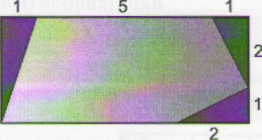

This illustration reproduced from National Council of Teachers of Mathematics, "Area Formulas," NCTM Illuminations, 2000–2008, http://illuminations.nctm.org/LessonDetail.aspx?ID=583 (Accessed April 2008). Used with permission.

If a student appears to have difficulty with these tasks, consider further individual assessment, such as a structured interview, to determine the student’s level of skill and understanding. See Sample Structured Interview: Assessing Prior Knowledge and Skills (p. 4).

Sample Structured Interview: Assessing Prior Knowledge and Skills for Activities 1 and 2

Directions | Date:
Directions | Not Quite There | Ready to Apply
1. Do triangles with the same base have the same area? Give reasons for your solution, including diagrams. | 1. Student responds, "yes." | 1. Student responds with clear diagrams that show as the height of the triangle changes, so does the area, regardless of whether the base is the same or not.
2. The formula for finding the area of a rectangle and the area of a parallelogram is the same. What relationship is there between these two polygons that allows this to happen? Give reasons for your explanation, including diagrams. | 2. Student does not understand the relationship between a rectangle and a parallelogram. Student simply applies formulas without any understanding. | 2. Student responds with the understanding that a parallelogram can always be transformed into a rectangle with the same base and height as pictured below.  Adapted from John A. Van de Walle, LouAnn H. Lovin, Teaching Student-Centered Mathematics: Grades 5–8, 1e (p. 255). Published by Allyn and Bacon, Boston, MA. Copyright © 2006 by Pearson Education. Reprinted by permission of the publisher.

Sample Structured Interview: Assessing Prior Knowledge and Skills for Activities 3 to 6

Directions | Date:
Directions | Not Quite There | Ready to Apply
3. Estimation Quickie: Select a single object such as a box, a watermelon, a jar or even the principal. Each day, select a different attribute or dimension to estimate. For example, students can estimate the length, weight or circumference around the middle section of a watermelon.  Adapted from John A. Van de Walle, LouAnn H. Lovin, Teaching Student-Centered Mathematics: Grades 5–8, 1e (p. 235). Published by Allyn and Bacon, Boston, MA. Copyright © 2006 by Pearson Education. Reprinted by permission of the publisher. | 3. Student is unsure of which attribute is to be used and has difficulty connecting attribute to proper units; e.g., length of watermelon to centimetres, volume of watermelon to cubic centimetres. | 3. Student clearly understands which attribute to use and clearly connects attribute to correct units; e.g., weight of watermelon to kilograms.
4. Estimate the length of the room pictured in Step 3, Part A, Activity 4 using the attributes of:  - windows  - bulletin board  - cabinet | 4. Student does not understand how to compare the attributes of the objects given to the length of the room. | 4. Student clearly answers that the room is approximately four windows long, three bulletin boards long and three and a little bit cabinets long.
5. a. Which shape shown in Step 3, Part A, Activity 5 has the greatest area? Why? | 5. a. Student chooses A or C. Student could be confusing area and perimeter. | 5. a. Student chooses Shape B. Explanation: All three shapes appear to have similar diameters. Shape B is a full circle; whereas shapes A and C appear to have pieces missing.
5. b. How could you find the area of Figure A shown in Step 3, Part A, Activity 5? | 5. b. Student makes reference to distance around “fingers”—indicating confusion with area and perimeter. | 5. b. Possible answers:  - Place a grid on top of Shape A and count units.  - Find the area of one of the fingers from the grid and multiply by 7.
6. Have the students determine the area of a shape that is drawn within a rectangle, such as the pentagon in the rectangle shown in Step 3, Part A, Activity 6 (p. 9). | 6. Student:  - is able to recognize shapes of a rectangle, triangle and pentagon  - is able to calculate the area of the rectangle and explain answer  - is able to recognize triangular shapes, but is unable to find area and cannot explain why OR attempts to break pentagon into a parallelogram and a triangle; gives a correct response and explanation for the area of the parallelogram, but guesses at the height of the triangle formed. | 6. Student:  - is able to calculate the area of the rectangle to be 21 square units and can explain why  - is able to calculate the area of the three triangles to be 1 square unit + 1 square unit + 1.5 square units  - calculates the total area of the triangles to be 3.5 square units and can explain why  - is able to calculate area of pentagon by subtracting area of triangles from area of rectangle to get 17.5 square units and can explain why.

