Graphic Organizer #31

Enter text into the fields below.

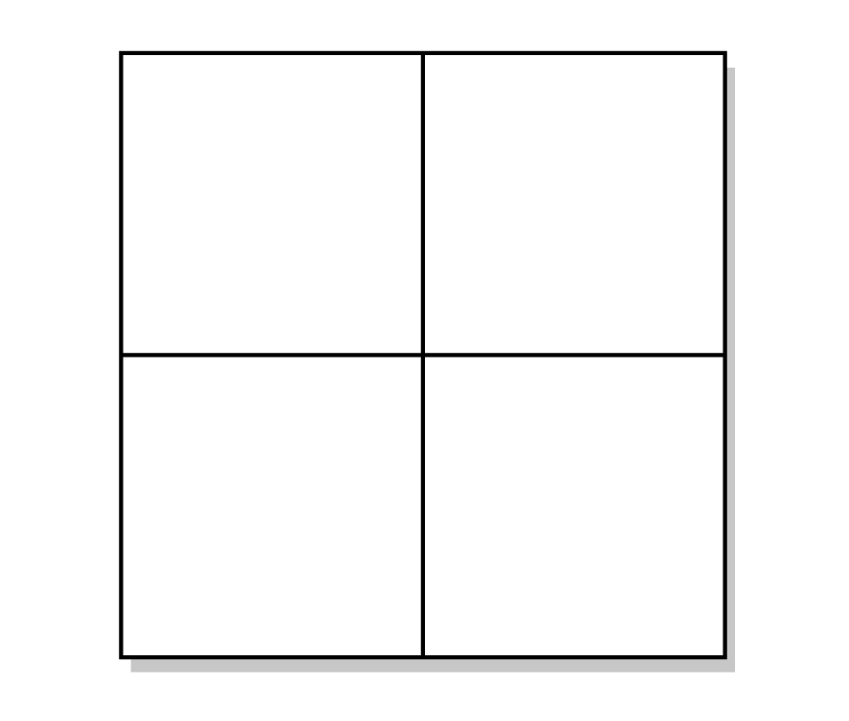
Text…
Text…
Text…
Text…

