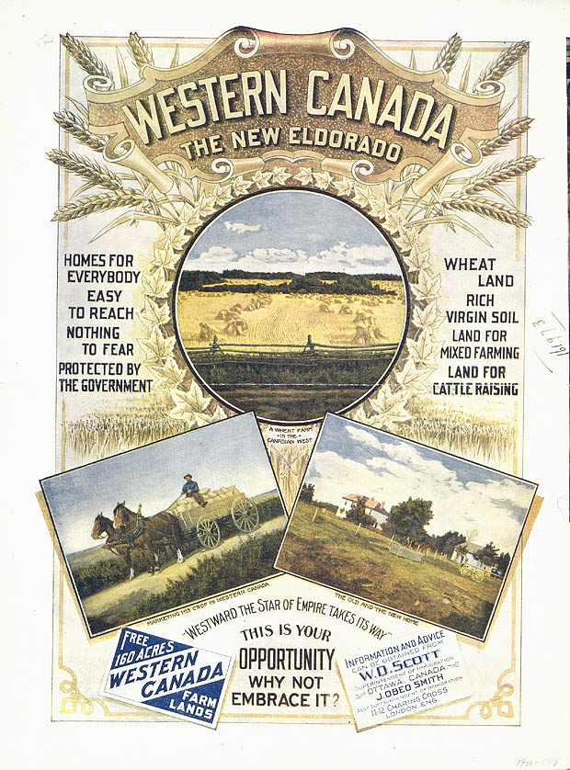
CAPTIVATING
-uses buzz words “The New Eldorado”
INFORMATIVE
Important information that settlers want to know
INFORMATIVE
Contact information for the superintendent and the assistant
PERSUASIVE
Uses “regular folks” since everyone has the opportunity
PERSUASIVE
Uses positive symbols like blue skies, sunshine, crops, wheat, maple leaves, large new home
PERSUASIVE
Lots of reasons why people would want to move to western Canada

