Opportunities, Challenges and Interesting Implications Chart

Opportunities | Challenges | Interesting  Implications
 Idea should move forward because…
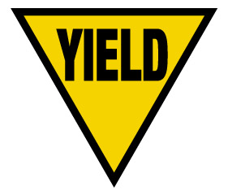 Move forward but with caution because…
 Idea does not warrant further consideration because…

