Use this page to track image usage or record descriptions. This document can be adapted for your needs and re-saved.

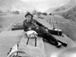 | Canada: Shaping an Identity Image 1
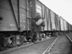 | Canada: Shaping an Identity Image 2
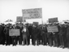 | Canada: Shaping an Identity Image 3
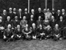 | Canada: Shaping an Identity Image 4
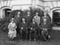 | Canada: Shaping an Identity Image 5
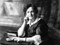 | Canada: Shaping an Identity Image 6
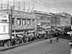 | Canada: Shaping an Identity Image 7
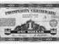 | Canada: Shaping an Identity Image 8
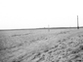 | Canada: Shaping an Identity Image 9

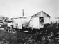 | Canada: Shaping an Identity Image 10
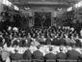 | Canada: Shaping an Identity Image 11
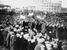 | Canada: Shaping an Identity Image 12
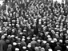 | Canada: Shaping an Identity Image 13
 | Canada: Shaping an Identity Image 14
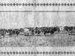 | Canada: Shaping an Identity Image 15
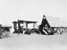 | Canada: Shaping an Identity Image 16
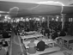 | Canada: Shaping an Identity Image 17
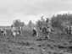 | Canada: Shaping an Identity Image 18
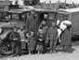 | Canada: Shaping an Identity Image 19
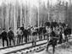 | Canada: Shaping an Identity Image 20
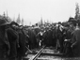 | Canada: Shaping an Identity Image 21
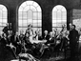 | Canada: Shaping an Identity Image 22
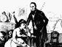 | Canada: Shaping an Identity Image 23
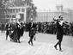 | Canada: Shaping an Identity Image 24
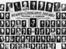 | Canada: Shaping an Identity Image 25
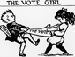 | Canada: Shaping an Identity Image 26
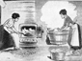 | Canada: Shaping an Identity Image 27
 | Canada: Shaping an Identity Image 28
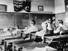 | Canada: Shaping an Identity Image 29

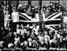 | Canada: Shaping an Identity Image 30
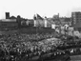 | Canada: Shaping an Identity Image 31
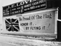 | Canada: Shaping an Identity Image 32
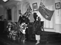 | Canada: Shaping an Identity Image 33
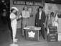 | Canada: Shaping an Identity Image 34
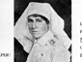 | Canada: Shaping an Identity Image 35
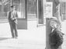 | Canada: Shaping an Identity Image 36
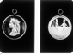 | Canada: Shaping an Identity Image 37
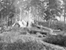 | Canada: Shaping an Identity Image 38
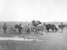 | Canada: Shaping an Identity Image 39
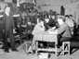 | Canada: Shaping an Identity Image 40
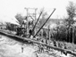 | Canada: Shaping an Identity Image 41
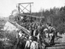 | Canada: Shaping an Identity Image 42
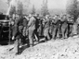 | Canada: Shaping an Identity Image 43
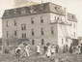 | Canada: Shaping an Identity Image 44
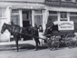 | Canada: Shaping an Identity Image 45
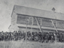 | Canada: Shaping an Identity Image 46
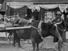 | Canada: Shaping an Identity Image 47
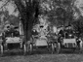 | Canada: Shaping an Identity Image 48
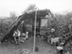 | Canada: Shaping an Identity Image 49

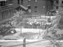 | Canada: Shaping an Identity Image 50
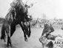 | Canada: Shaping an Identity Image 51

