Use this page to track image usage or record descriptions. This document can be adapted for your needs and re-saved.

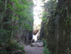 | Eastern Canada Image 1
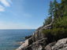 | Eastern Canada Image 2
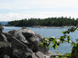 | Eastern Canada Image 3
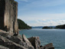 | Eastern Canada Image 4
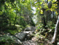 | Eastern Canada Image 5
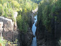 | Eastern Canada Image 6
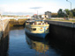 | Eastern Canada Image 7
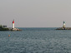 | Eastern Canada Image 8
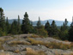 | Eastern Canada Image 9

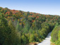 | Eastern Canada Image 10
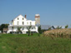 | Eastern Canada Image 11
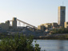 | Eastern Canada Image 12
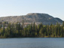 | Eastern Canada Image 13
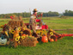 | Eastern Canada Image 14
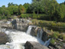 | Eastern Canada Image 15
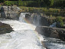 | Eastern Canada Image 16
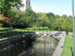 | Eastern Canada Image 17
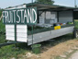 | Eastern Canada Image 18
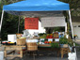 | Eastern Canada Image 19
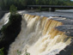 | Eastern Canada Image 20
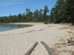 | Eastern Canada Image 21
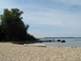 | Eastern Canada Image 22
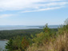 | Eastern Canada Image 23
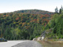 | Eastern Canada Image 24
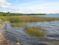 | Eastern Canada Image 25
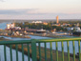 | Eastern Canada Image 26
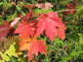 | Eastern Canada Image 27
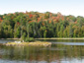 | Eastern Canada Image 28
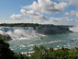 | Eastern Canada Image 29

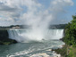 | Eastern Canada Image 30
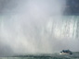 | Eastern Canada Image 31
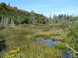 | Eastern Canada Image 32
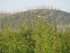 | Eastern Canada Image 33
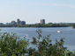 | Eastern Canada Image 34
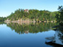 | Eastern Canada Image 35
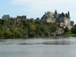 | Eastern Canada Image 36
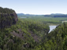 | Eastern Canada Image 37
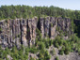 | Eastern Canada Image 38
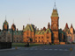 | Eastern Canada Image 39
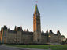 | Eastern Canada Image 40
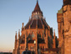 | Eastern Canada Image 41
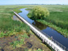 | Eastern Canada Image 42
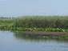 | Eastern Canada Image 43
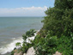 | Eastern Canada Image 44
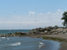 | Eastern Canada Image 45
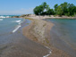 | Eastern Canada Image 46
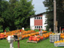 | Eastern Canada Image 47
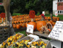 | Eastern Canada Image 48
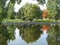 | Eastern Canada Image 49

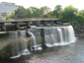 | Eastern Canada Image 50
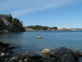 | Eastern Canada Image 51
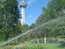 | Eastern Canada Image 52
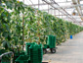 | Eastern Canada Image 53
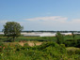 | Eastern Canada Image 54
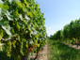 | Eastern Canada Image 55
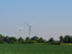 | Eastern Canada Image 56
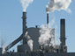 | Eastern Canada Image 57
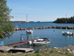 | Eastern Canada Image 58
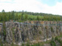 | Eastern Canada Image 59
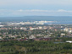 | Eastern Canada Image 60
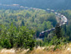 | Eastern Canada Image 61
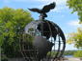 | Eastern Canada Image 62
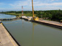 | Eastern Canada Image 63
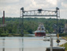 | Eastern Canada Image 64
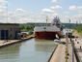 | Eastern Canada Image 65
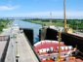 | Eastern Canada Image 66
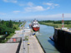 | Eastern Canada Image 67
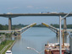 | Eastern Canada Image 68
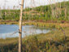 | Eastern Canada Image 69

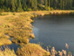 | Eastern Canada Image 70
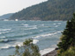 | Eastern Canada Image 71
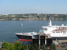 | Eastern Canada Image 72
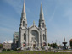 | Eastern Canada Image 73
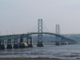 | Eastern Canada Image 74
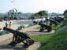 | Eastern Canada Image 75
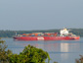 | Eastern Canada Image 76

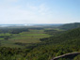 | Eastern Canada Image 77
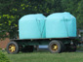 | Eastern Canada Image 78

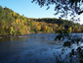 | Eastern Canada Image 79
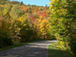 | Eastern Canada Image 80
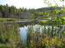 | Eastern Canada Image 81
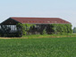 | Eastern Canada Image 82
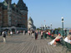 | Eastern Canada Image 83
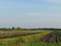 | Eastern Canada Image 84
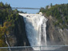 | Eastern Canada Image 85
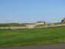 | Eastern Canada Image 86
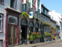 | Eastern Canada Image 87

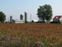 | Eastern Canada Image 88
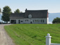 | Eastern Canada Image 89
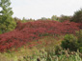 | Eastern Canada Image 90
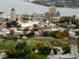 | Eastern Canada Image 91 | _____________________________________________________________________________________________________________________________________________
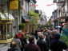 | Eastern Canada Image 92 | __________________________________________________________________________________________________________________________________________
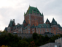 | Eastern Canada Image 93 | __________________________________________________________________________________________________________________________________________
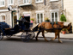 | Eastern Canada Image 94 | __________________________________________________________________________________________________________________________________________
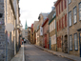 | Eastern Canada Image 95 | __________________________________________________________________________________________________________________________________________
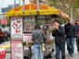 | Eastern Canada Image 96 | __________________________________________________________________________________________________________________________________________
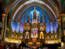 | Eastern Canada Image 97 | __________________________________________________________________________________________________________________________________________
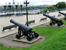 | Eastern Canada Image 98 | __________________________________________________________________________________________________________________________________________
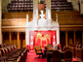 | Eastern Canada Image 99 | __________________________________________________________________________________________________________________________________________
 | Eastern Canada Image 100 | __________________________________________________________________________________________________________________________________________
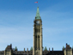 | Eastern Canada Image 101 | __________________________________________________________________________________________________________________________________________

