Use this page to track image usage or record descriptions. This document can be adapted for your needs and re-saved.

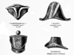 | Toward Confederation Image 1
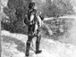 | Toward Confederation Image 2
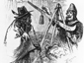 | Toward Confederation Image 3
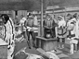 | Toward Confederation Image 4
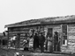 | Toward Confederation Image 5
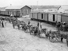 | Toward Confederation Image 6
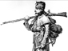 | Toward Confederation Image 7
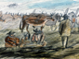 | Toward Confederation Image 8
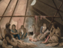 | Toward Confederation Image 9

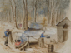 | Toward Confederation Image 10
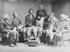 | Toward Confederation Image 11
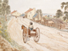 | Toward Confederation Image 12
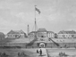 | Toward Confederation Image 13
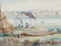 | Toward Confederation Image 14
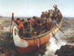 | Toward Confederation Image 15
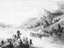 | Toward Confederation Image 16
 | Toward Confederation Image 17
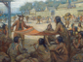 | Toward Confederation Image 18
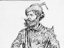 | Toward Confederation Image 19
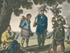 | Toward Confederation Image 20
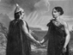 | Toward Confederation Image 21
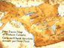 | Toward Confederation Image 22
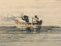 | Toward Confederation Image 23
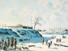 | Toward Confederation Image 24
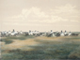 | Toward Confederation Image 25
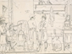 | Toward Confederation Image 26
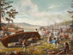 | Toward Confederation Image 27
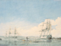 | Toward Confederation Image 28
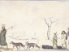 | Toward Confederation Image 29

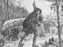 | Toward Confederation Image 30
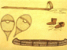 | Toward Confederation Image 31
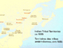 | Toward Confederation Image 32
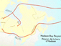 | Toward Confederation Image 33
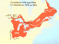 | Toward Confederation Image 34
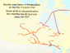 | Toward Confederation Image 35
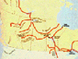 | Toward Confederation Image 36
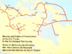 | Toward Confederation Image 37
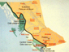 | Toward Confederation Image 38
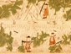 | Toward Confederation Image 39
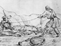 | Toward Confederation Image 40
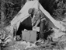 | Toward Confederation Image 41
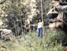 | Toward Confederation Image 42
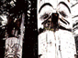 | Toward Confederation Image 43
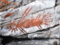 | Toward Confederation Image 44
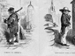 | Toward Confederation Image 45
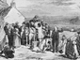 | Toward Confederation Image 46
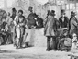 | Toward Confederation Image 47
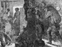 | Toward Confederation Image 48
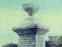 | Toward Confederation Image 49

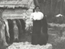 | Toward Confederation Image 50
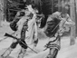 | Toward Confederation Image 51
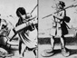 | Toward Confederation Image 52
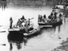 | Toward Confederation Image 53

