Use this page to track image usage or record descriptions. This document can be adapted for your needs and re-saved.

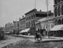 | Ways of Life in Canada Image 1
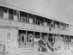 | Ways of Life in Canada Image 2
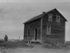 | Ways of Life in Canada Image 3
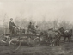 | Ways of Life in Canada Image 4
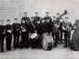 | Ways of Life in Canada Image 5
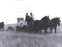 | Ways of Life in Canada Image 6
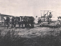 | Ways of Life in Canada Image 7
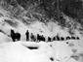 | Ways of Life in Canada Image 8
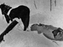 | Ways of Life in Canada Image 9

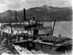 | Ways of Life in Canada Image 10
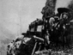 | Ways of Life in Canada Image 11
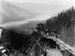 | Ways of Life in Canada Image 12
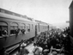 | Ways of Life in Canada Image 13
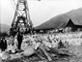 | Ways of Life in Canada Image 14
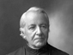 | Ways of Life in Canada Image 15
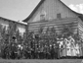 | Ways of Life in Canada Image 16
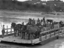 | Ways of Life in Canada Image 17
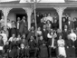 | Ways of Life in Canada Image 18
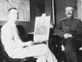 | Ways of Life in Canada Image 19
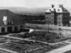 | Ways of Life in Canada Image 20
 | Ways of Life in Canada Image 21
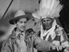 | Ways of Life in Canada Image 22
 | Ways of Life in Canada Image 23
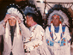 | Ways of Life in Canada Image 24
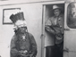 | Ways of Life in Canada Image 25
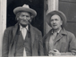 | Ways of Life in Canada Image 26
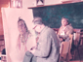 | Ways of Life in Canada Image 27
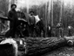 | Ways of Life in Canada Image 28
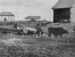 | Ways of Life in Canada Image 29

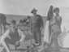 | Ways of Life in Canada Image 30
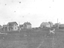 | Ways of Life in Canada Image 31
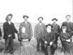 | Ways of Life in Canada Image 32
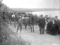 | Ways of Life in Canada Image 33
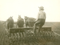 | Ways of Life in Canada Image 34
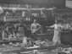 | Ways of Life in Canada Image 35
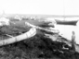 | Ways of Life in Canada Image 36
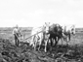 | Ways of Life in Canada Image 37
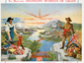 | Ways of Life in Canada Image 38
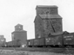 | Ways of Life in Canada Image 39
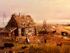 | Ways of Life in Canada Image 40
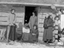 | Ways of Life in Canada Image 41
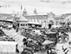 | Ways of Life in Canada Image 42
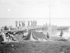 | Ways of Life in Canada Image 43
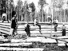 | Ways of Life in Canada Image 44
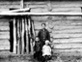 | Ways of Life in Canada Image 45
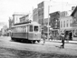 | Ways of Life in Canada Image 46
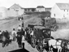 | Ways of Life in Canada Image 47
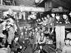 | Ways of Life in Canada Image 48
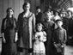 | Ways of Life in Canada Image 49

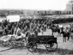 | Ways of Life in Canada Image 50
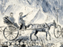 | Ways of Life in Canada Image 51
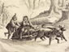 | Ways of Life in Canada Image 52
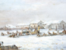 | Ways of Life in Canada Image 53
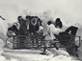 | Ways of Life in Canada Image 54
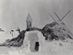 | Ways of Life in Canada Image 55
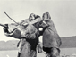 | Ways of Life in Canada Image 56
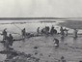 | Ways of Life in Canada Image 57
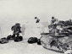 | Ways of Life in Canada Image 58
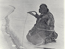 | Ways of Life in Canada Image 59
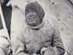 | Ways of Life in Canada Image 60
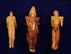 | Ways of Life in Canada Image 61
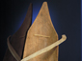 | Ways of Life in Canada Image 62
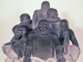 | Ways of Life in Canada Image 63
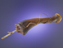 | Ways of Life in Canada Image 64
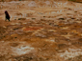 | Ways of Life in Canada Image 65
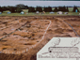 | Ways of Life in Canada Image 66
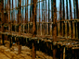 | Ways of Life in Canada Image 67
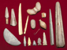 | Ways of Life in Canada Image 68
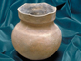 | Ways of Life in Canada Image 69
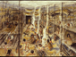 | Ways of Life in Canada Image 70
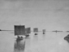 | Ways of Life in Canada Image 71
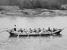 | Ways of Life in Canada Image 72
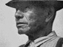 | Ways of Life in Canada Image 73
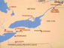 | Ways of Life in Canada Image 74
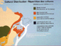 | Ways of Life in Canada Image 75
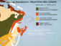 | Ways of Life in Canada Image 76
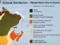 | Ways of Life in Canada Image 77
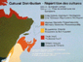 | Ways of Life in Canada Image 78

