Use this page to track image usage or record descriptions. This document can be adapted for your needs and re-saved.
 | Community Image 1
 | Community Image 2
 | Community Image 3
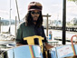 | Community Image 4
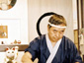 | Community Image 5
 | Community Image 6
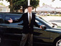 | Community Image 7
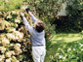 | Community Image 8
 | Community Image 9
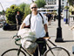 | Community Image 10
Reproduced with permission from The Critical Thinking Consortium.
Image Collection photographs may be used freely in any non-profit educational context provided a credit to the source is included in your work. Any other use requires written permission from the copyright holder. Third-party images are identified by a credit to the copyright holder.

