Use this page to track image usage or record descriptions. This document can be adapted for your needs and re-saved.

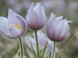 | Dry Island Image 1
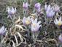 | Dry Island Image 2
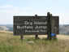 | Dry Island Image 3
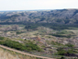 | Dry Island Image 4
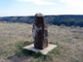 | Dry Island Image 5
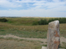 | Dry Island Image 6
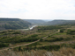 | Dry Island Image 7
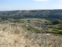 | Dry Island Image 8
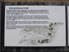 | Dry Island Image 9

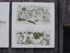 | Dry Island Image 10
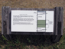 | Dry Island Image 11
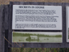 | Dry Island Image 12
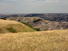 | Dry Island Image 13
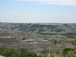 | Dry Island Image 14
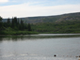 | Dry Island Image 15
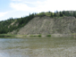 | Dry Island Image 16
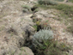 | Dry Island Image 17
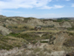 | Dry Island Image 18
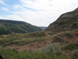 | Dry Island Image 19
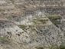 | Dry Island Image 20
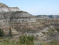 | Dry Island Image 21
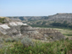 | Dry Island Image 22
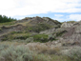 | Dry Island Image 23
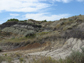 | Dry Island Image 24
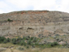 | Dry Island Image 25
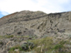 | Dry Island Image 26
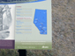 | Dry Island Image 27
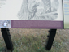 | Dry Island Image 28
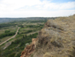 | Dry Island Image 29

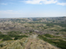 | Dry Island Image 30
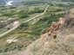 | Dry Island Image 31
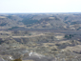 | Dry Island Image 32
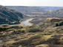 | Dry Island Image 33
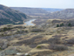 | Dry Island Image 34
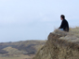 | Dry Island Image 35
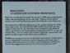 | Dry Island Image 36
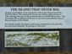 | Dry Island Image 37
 | Dry Island Image 38

