Use this page to track image usage or record descriptions. This document can be adapted for your needs and re-saved.

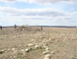 | Rumsey Image 1
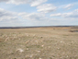 | Rumsey Image 2
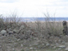 | Rumsey Image 3
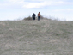 | Rumsey Image 4
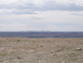 | Rumsey Image 5
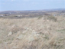 | Rumsey Image 6
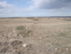 | Rumsey Image 7
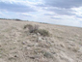 | Rumsey Image 8
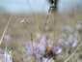 | Rumsey Image 9

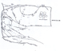 | Rumsey Image 10
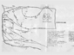 | Rumsey Image 11

