Use this page to track image usage or record descriptions. This document can be adapted for your needs and re-saved.
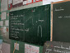 | Tunisia Image 1
 | Tunisia Image 2
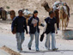 | Tunisia Image 3
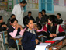 | Tunisia Image 4
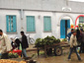 | Tunisia Image 5  Kairouan
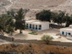 | Tunisia Image 6
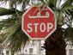 | Tunisia Image 7
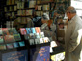 | Tunisia Image 8
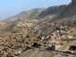 | Tunisia Image 9

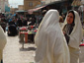 | Tunisia Image 10
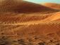 | Tunisia Image 11  Sahara Desert
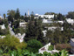 | Tunisia Image 12  Carthage
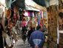 | Tunisia Image 13
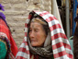 | Tunisia Image 14
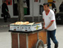 | Tunisia Image 15
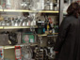 | Tunisia Image 16
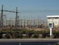 | Tunisia Image 17
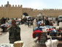 | Tunisia Image 18
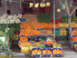 | Tunisia Image 19
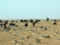 | Tunisia Image 20
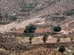 | Tunisia Image 21
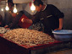 | Tunisia Image 22
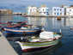 | Tunisia Image 23  Bizerte
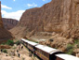 | Tunisia Image 24
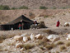 | Tunisia Image 25
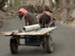 | Tunisia Image 26
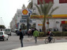 | Tunisia Image 27
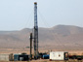 | Tunisia Image 28
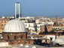 | Tunisia Image 29

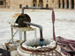 | Tunisia Image 30
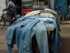 | Tunisia Image 31
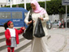 | Tunisia Image 32
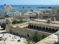 | Tunisia Image 33
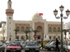 | Tunisia Image 34  Sfax
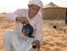 | Tunisia Image 35
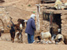 | Tunisia Image 36
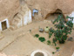 | Tunisia Image 37
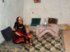 | Tunisia Image 38
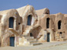 | Tunisia Image 39
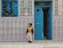 | Tunisia Image 40
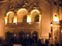 | Tunisia Image 41
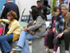 | Tunisia Image 42
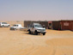 | Tunisia Image 43
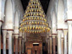 | Tunisia Image 44
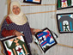 | Tunisia Image 45
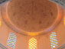 | Tunisia Image 46
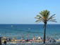 | Tunisia Image 47
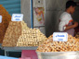 | Tunisia Image 48
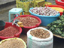 | Tunisia Image 49

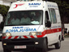 | Tunisia Image 50
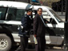 | Tunisia Image 51
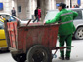 | Tunisia Image 52
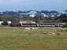 | Tunisia Image 53
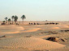 | Tunisia Image 54
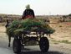 | Tunisia Image 55
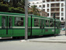 | Tunisia Image 56
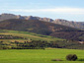 | Tunisia Image 57
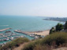 | Tunisia Image 58
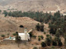 | Tunisia Image 59
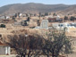 | Tunisia Image 60
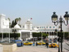 | Tunisia Image 61
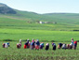 | Tunisia Image 62
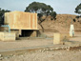 | Tunisia Image 63
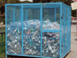 | Tunisia Image 64  Tunis
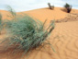 | Tunisia Image 65  Sahara Desert
Reproduced with permission from DiversityWorks Publishing.

Image Collection photographs may be used freely in any non-profit educational context provided a credit to the source is included in your work. Any other use requires written permission from the copyright holder. Third-party images are identified by a credit to the copyright holder.

